MCALE322 Deep Learning Lab INDEX
Sr. No | Name of the Experiment | Date | CO | Sign
1 | Introduction to Tensor flow /Keras – Demonstrate Importing Libraries and Modules using Tensor flow/Keras |  | CO1
2 | Demonstrate how we can Load the dataset, splitting dataset into training and testing data sets. |  | CO2
3 | Implementation of Data preprocessing techniques. |  | CO2
4 | Implementation of Artificial Neural Networks –  - McCulloch-Pitts neuron with ANDNOT function,  - Back propagation Network for XOR function with Binary Input and Output. |  | CO2
5 | Implementation of Regularization Techniques- Dataset Augmentation, Early Stopping, Dropout. |  | CO3
6 | Implementation and analysis of Deep Neural network algorithm: Convolutional neural network (CNN) –  - Object identification and classification  - Image recognition/prediction from in build dataset and predict the loaded image from local machine. |  | CO4
7 | Implementation and analysis of Deep Neural network algorithm: Recurrent neural network (RNN) –  - Character recognition and prediction  - web traffic Image classification. |  | CO4
8 | LSTM Network: Sentiment analysis using LSTM |  | CO4

Practical No. 1
Import Tensor Flow And Keras
1. Installing and Importing Libraries
- TensorFlow & Keras: Frameworks for deep learning.
- NumPy: For numerical operations (arrays, matrices).
- Matplotlib: For plotting and visualizing images.
2. Working with NumPy Arrays
- You created 1D, 2D, 3D, and 4D arrays.
- Checked:
  - ndim → number of dimensions (1D, 2D, 3D, etc.).
  - shape → structure of the array (rows, columns, etc.).
  - dtype → type of elements (int, float).
3. Creating Tensors in TensorFlow
- You defined constant tensors (a and b).
- Performed:
  - Addition (tf.add) → element-wise addition.
  - Matrix multiplication (tf.matmul) → like multiplying two matrices in math.
4. Loading the MNIST Dataset
- MNIST = dataset of handwritten digits (0–9).
- Contains:
  - 60,000 training images
  - 10,000 test images
  - Each image = 28 × 28 pixels (grayscale).
- Checked ndim, shape, dtype of images.
!pip install tensorflow

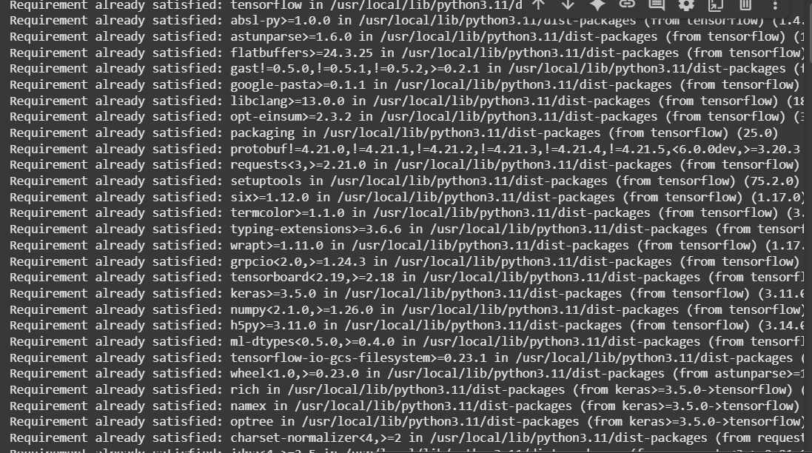
import tensorflow as tf
from tensorflow import keras
print("Tensorflow Version:", tf.__version__)
print("Keras Version:", keras.__version__)
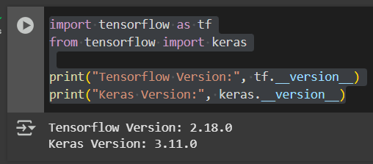
! pip install tensorflow-datasets==4.6.0

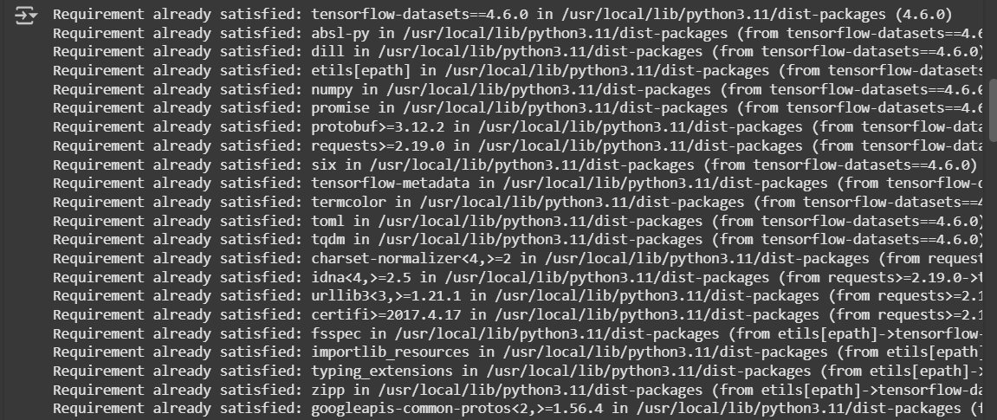
! pip install keras==2.10.0
!pip install tensorflow-estimator==2.10.0
!pip install protobuf==3.19.6
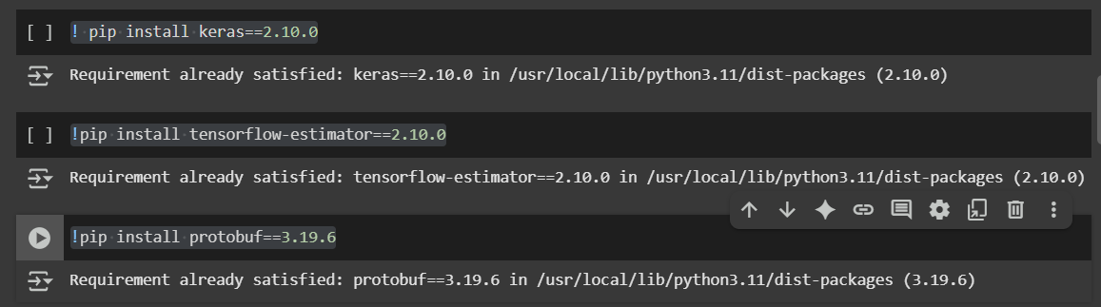
import numpy as np
x = np.array(12)
x = np.array([32, 24, 55, 7, 8])
print(x)
print(x.ndim)
print(x.shape)
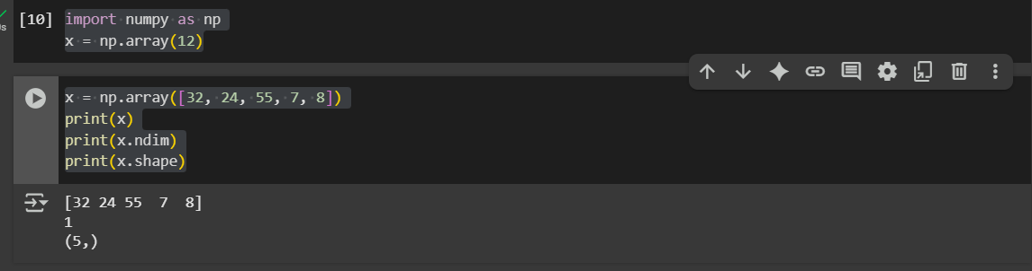
x =np.array([[32, 45, 76, 87, 94],
[67, 81, 32, 69, 8],
[32, 76, 98, 54, 8]])
x.ndim
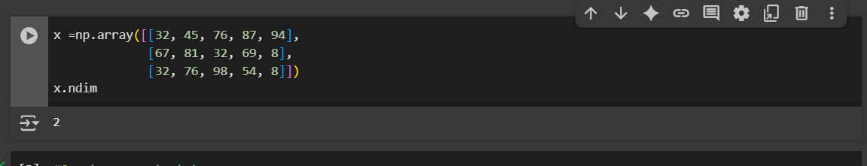
#Create a constant tensor
a = tf.constant([[1, 2], [3, 4]])
b = tf.constant([[5, 6], [7, 8]])
print("Addition:\n", tf.add(a,b))
print("Multtiplication:\n", tf.matmul(a,b))
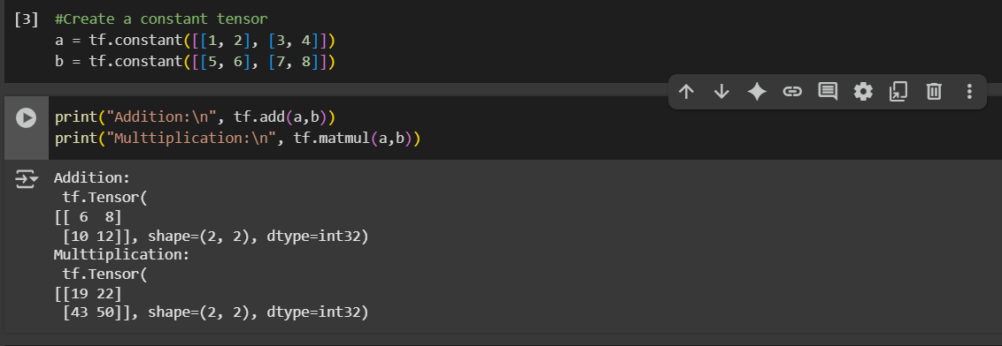
x = np. array([[[32, 67, 87, 78, 89],
[78, 97, 65, 54, 66],
[32, 78, 54, 42, 12]],

[[32, 45, 78, 96, 86],
[95, 74, 88, 85, 48],
[65, 89, 66, 43, 21]],

[[65, 76, 89, 61, 65],
[64, 87, 97, 54, 65],
[76, 74, 43, 41, 76]],

[[65, 76, 89, 61, 65],
[64, 87, 97, 54, 65],
[76, 74, 43, 41, 76]]
])
print(x.ndim)
print(x.shape)
print(x.dtype)
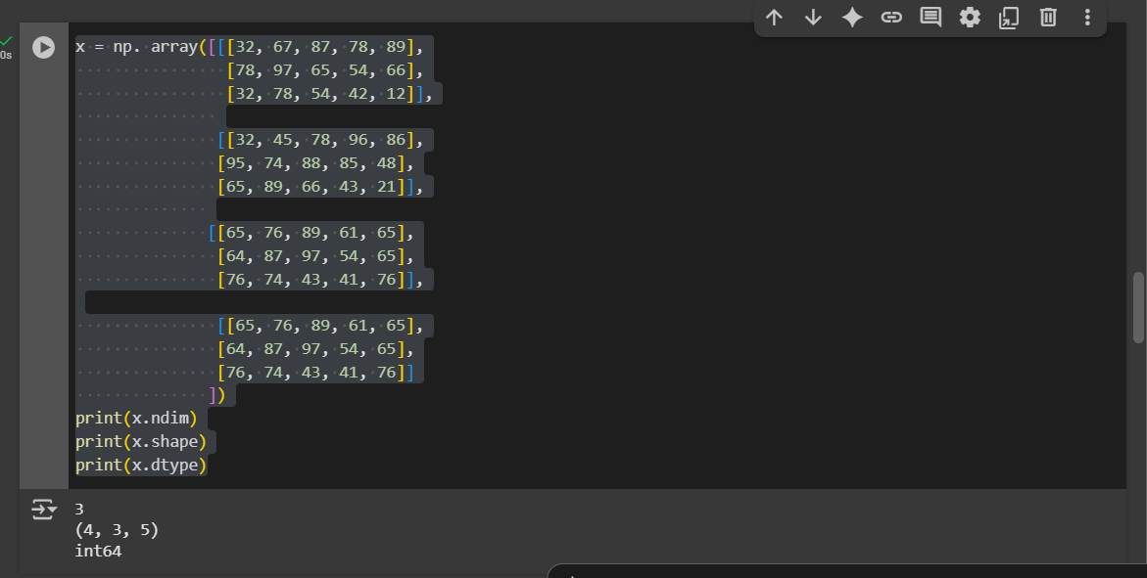
!pip install --upgrade tensorflow keras protobuf
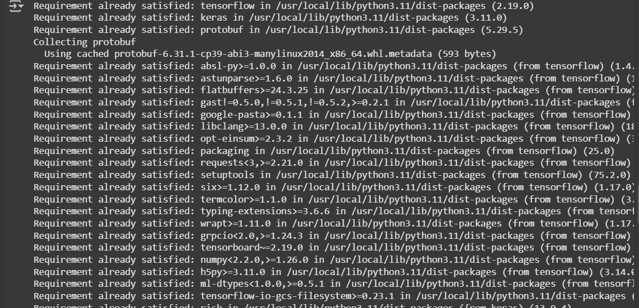
from keras.datasets import mnist
(train_images, train_labels), (test_images, test_labels) = mnist.load_data()
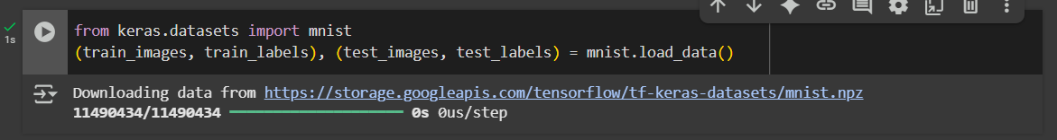
print(train_images.ndim) #There are 60,000 images where each image is a 28x28 pixel.
print(train_images.shape)
print(train_images.dtype)
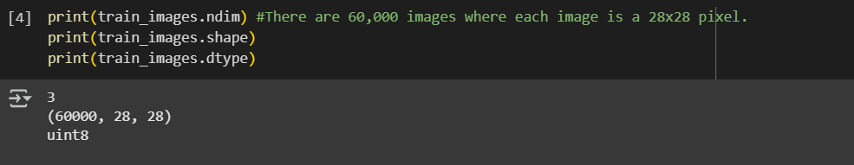
digit = train_images[0]

import matplotlib.pyplot as plt
plt.imshow(digit, cmap=plt.cm.binary)
plt.show()
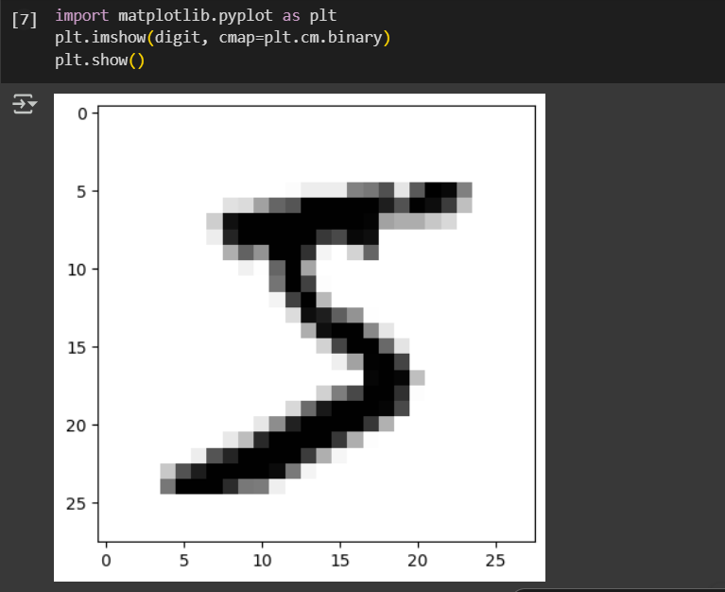
buttom_right_corner = train_images[:, 14:, 14:]
plt.imshow(buttom_right_corner[0], cmap=plt.cm.binary)
plt.show()
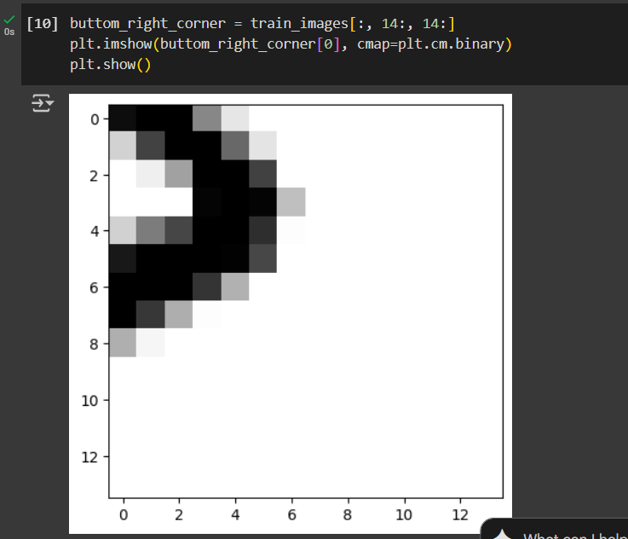
center_patches = train_images[:,7:-7, 7:-7]
plt.imshow(center_patches[0], cmap=plt.cm.binary)
plt.show()
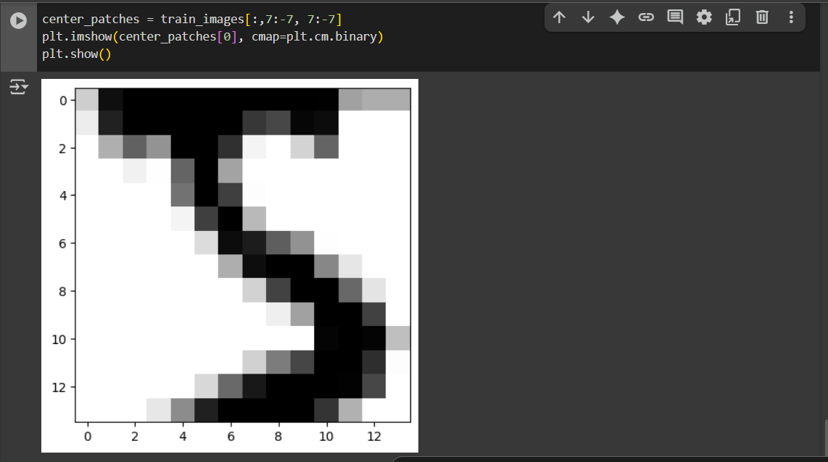

import tensorflow as tf
import numpy as np
import matplotlib.pyplot as plt
from tensorflow.keras.models import Sequential
from tensorflow.keras.layers import Flatten, Dense

(x_train, y_train), (x_test, y_test) = tf.keras.datasets.mnist.load_data()

print(x_train.shape, y_train.shape)
print(x_test.shape, y_test.shape)

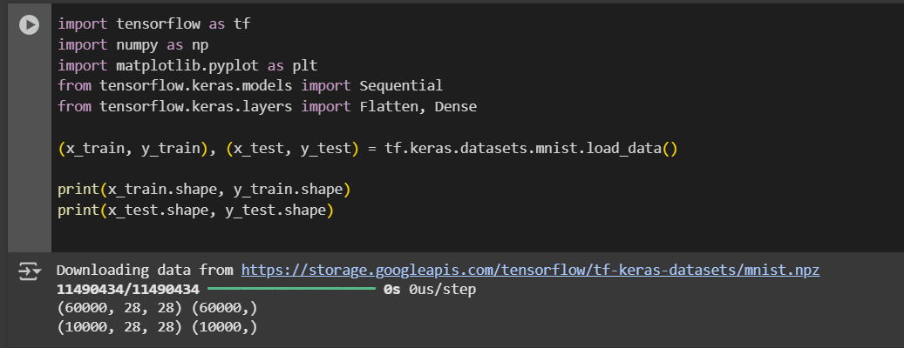
gray_scale = 255

x_train = x_train.astype('float32') / gray_scale
x_test = x_test.astype('float32') / gray_scale

print("feature matrix (x_train) : " , x_train.shape)
print("target matrix (y_train) : " , y_train.shape)
print("feature matrix (x_test) : " , x_test.shape)
print("target matrix (y_test) : " , y_test.shape)

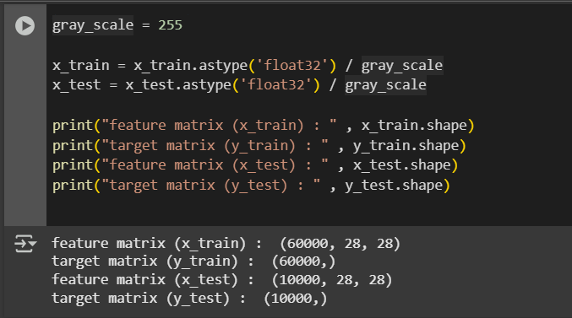
fig, ax = plt.subplots(10,10)
k = 0

for i in range(10):
for j in range(10):
ax[i][j].imshow(
x_train[k].reshape(28,28),
aspect = 'auto'
)
k += 1

plt.show()

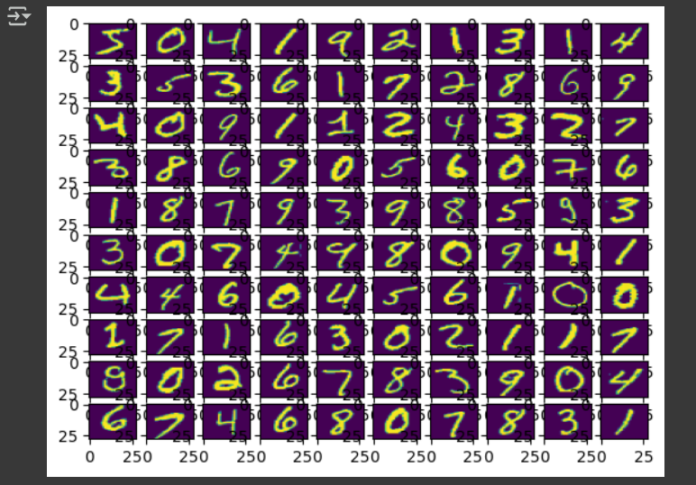
model = Sequential([
Flatten(input_shape=(28,28)),
Dense(256, activation='sigmoid'),
Dense(128, activation='sigmoid'),
Dense(10, activation='softmax')
])

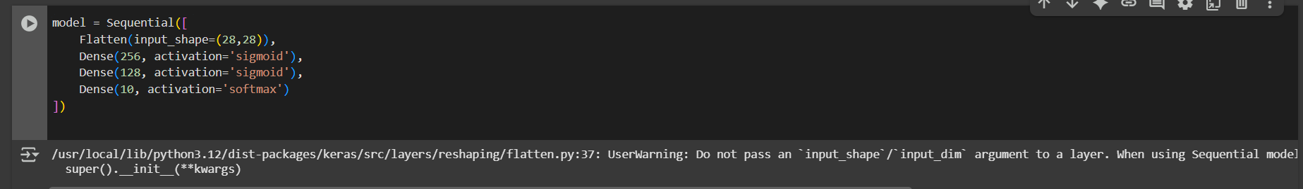
model.compile(
optimizer='adam',
loss='sparse_categorical_crossentropy',
metrics=['accuracy']
)

mod = model.fit(x_train, y_train, epochs=10, validation_split=0.2, batch_size = 2000)
print(mod)

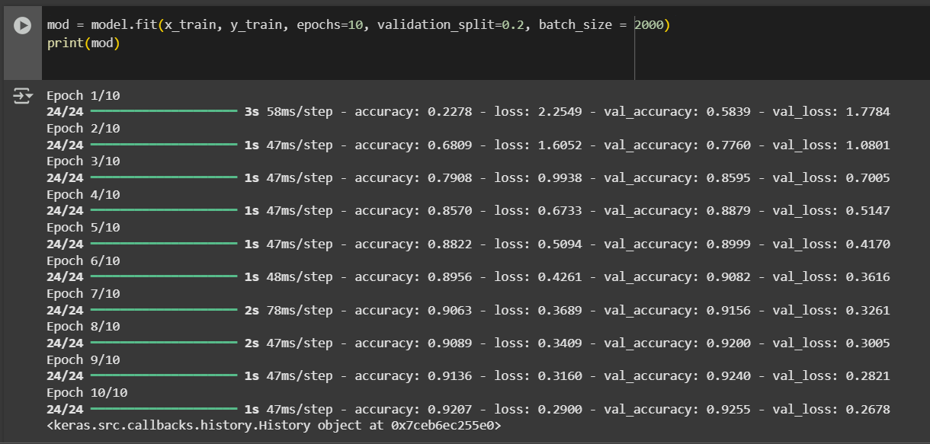
results = model.evaluate(x_test, y_test, verbose=0)
print("Test loss, Test accuracy : " ,results)

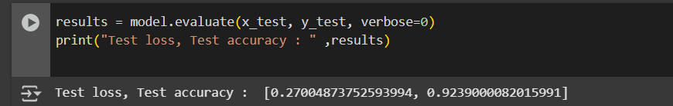
plt.figure(figsize=(12,5))

plt.subplot(1,2,1)
plt.plot(mod.history['accuracy'], label='Training Accuracy', color = 'blue')
plt.plot(mod.history['val_accuracy'], label='Validation Accuracy', color = 'orange')
plt.title("training and validation accuracy :",fontsize = 14)
plt.xlabel('Epochs', fontsize=12)
plt.ylabel('Accuracy',fontsize=12)
plt.legend()
plt.grid(True)

plt.subplot(1,2,2)
plt.plot(mod.history['loss'], label='Training Loss', color = 'blue')
plt.plot(mod.history['val_loss'], label='Validation Loss',color = 'orange')
plt.title("training and validation loss :",fontsize = 14)
plt.xlabel('Epochs', fontsize=12)
plt.ylabel('Loss', fontsize=12)
plt.legend()
plt.grid(True)
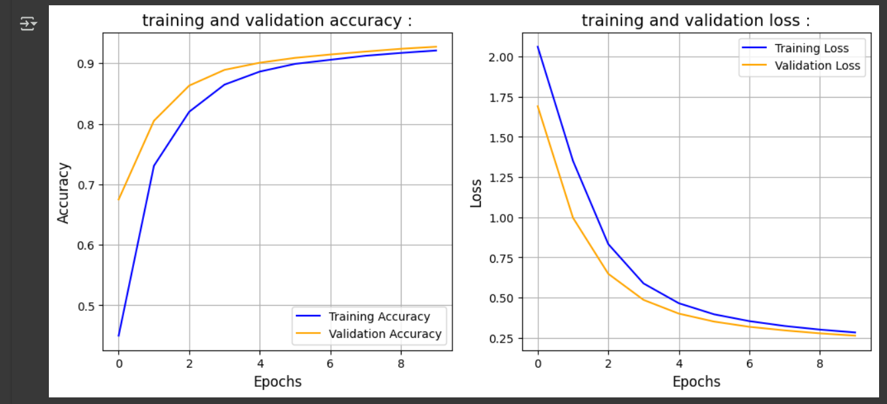

Slicing
5. Slicing Images
- You extracted parts of images:
  - Bottom-right corner.
  - Center patches.
  - Full slices from multiple images.
- This teaches array slicing in NumPy (important for image preprocessing).
6. Normalizing Data
- Divided pixel values by 255 (max grayscale value).
- Converts values from 0–255 → 0–1.
- This helps neural networks train better.
7. Visualizing Images
- Displayed first 100 images in a grid (10×10).
- Helps confirm the dataset is correctly loaded.
7. Visualizing Images
- Displayed first 100 images in a grid (10×10).
- Helps confirm the dataset is correctly loaded.
8. Building a Neural Network Model
- Used Sequential model with layers:
  - Flatten → converts 28×28 image into a single vector.
  - Dense (256 neurons, sigmoid) → hidden layer.
  - Dense (128 neurons, sigmoid) → hidden layer.
  - Dense (10 neurons, softmax) → output layer (10 digits).
9. Compiling the Model
- Optimizer: Adam (efficient gradient descent).
- Loss function: Sparse categorical crossentropy (for classification).
- Metric: Accuracy (to measure performance).
10. Training the Model
- Trained for 10 epochs (full passes over training data).
- Used validation split (20%) to check performance on unseen data during training.
- Batch size = 2000 images processed at once.
11. Evaluating the Model
- Tested on x_test, y_test.
- Reported Test Loss and Test Accuracy.
12. Plotting Training vs Validation
- Plotted graphs of:
  - Accuracy vs Epochs
  - Loss vs Epochs
- Helps you visually check for overfitting or underfitting.
13. Slicing, Batching, Broadcasting, and Reshaping
- Slicing: Selecting parts of arrays/images.
- Batching: Dividing dataset into smaller groups (like 128 images per batch).
- Broadcasting: NumPy automatically matches shapes for addition/multiplication.
- Reshaping & Transpose: Changing array shape or rotating it.

import numpy as np
import tensorflow as tf
from tensorflow import keras
x= np.array(14)
x.ndim
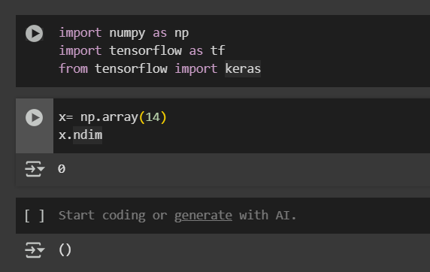
from keras.datasets import mnist
(train_images, train_labels), (test_images, test_labels) = mnist.load_data()
print(train_images.shape)
my_slice = train_images[10]
print(my_slice.shape)
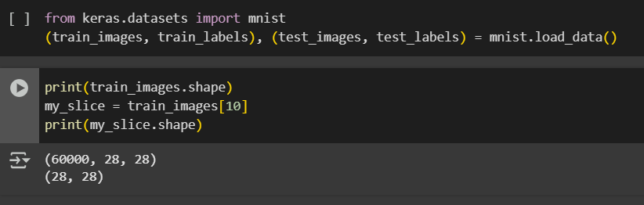
my_slice = train_images[10:100] #Selecting all imagesfrom 10th upto 100th
print(my_slice.shape) #We have selected 90 images
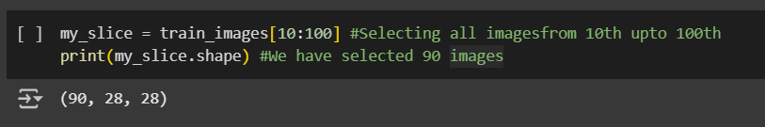
my_slice = train_images[10:100, 2:28, 0:28]
print(my_slice.shape)
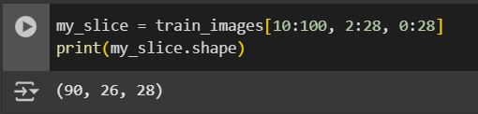
my_slice = train_images[:, 14:28, 14:28]
print(my_slice.shape)
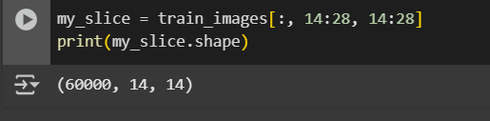
my_slice = train_images[:, 7:21, 7:21]
print(my_slice.shape)
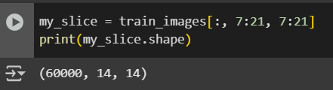
my_slice = train_images[:, 7:-7, 7:-7] #An alternate way to do the above operations
print(my_slice.shape)
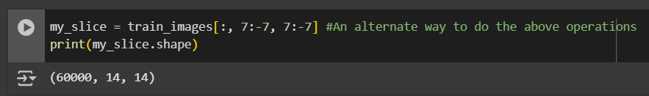
batch1 = train_images[0:128]
print(batch1.shape)
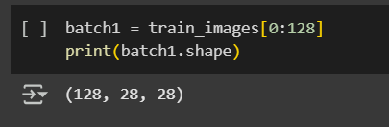
batch2 = train_images[128:256]
print(batch2.shape)
batch3 = train_images[256:384]
print(batch3.shape)
batch4 = train_images[384:512]
print(batch4.shape)
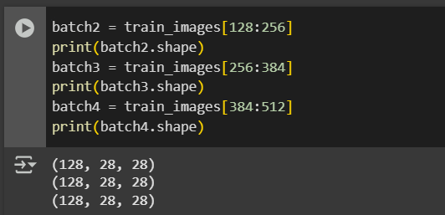
n = 0 #refers to the first batch
batch_n = train_images[128 * n : 128 * (n + 1)]
batch_n.shape
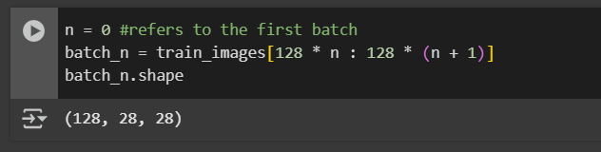
n = 1 #refers to the second batch
batch_n = train_images[128 * n : 128 * (n + 1)]
batch_n.shape
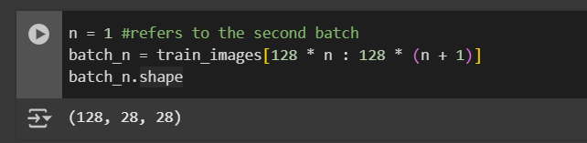
n = 2 #refers to the third batch
batch_n = train_images[128 * n : 128 * (n + 1)]
batch_n.shape
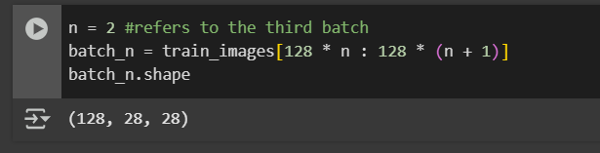
BroadCasting and Reshaping
# X is a 1D tensor with shape 4
x = np.array([1, 4, 6, 9])
print(x.shape)
x.ndim
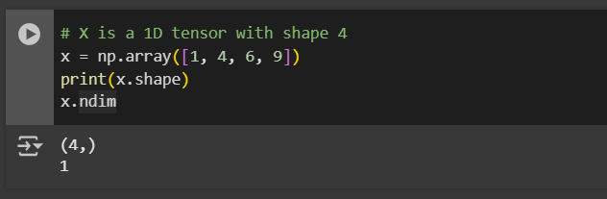
# y is a matrix i.e., a 2-D tensor with shape(3,4)
y = np.array([[34, 35, 36, 37], [44, 45, 46, 47], [54, 55, 56, 57]])
print(y.shape)
y.ndim
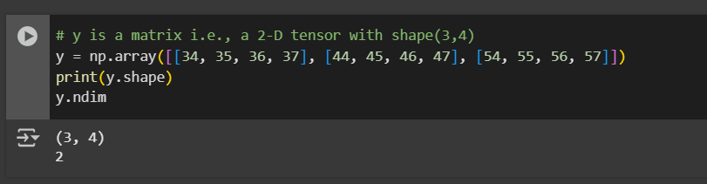
# They're not compatible for tensor operation of addition
# Because of implicit broadcasting, the x tensor tries to matches the dimension of y tensor
x + y
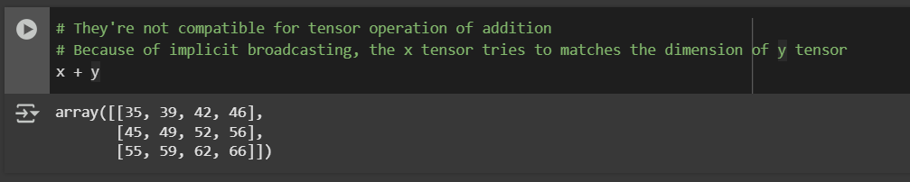
p = np.array([1, 2, 3, 4, 5])

q = np.array([[1, 2, 3, 4],
[]])
x = np.array([[1, 2, 3],
[4, 5, 6]])
x.shape
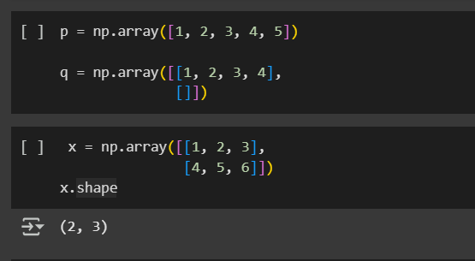
x = x.reshape((6,1))
x
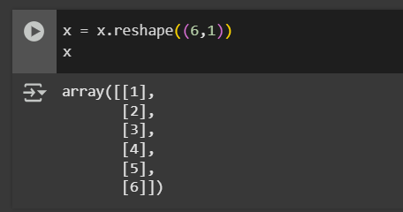
x = np.array([[0,1],
[2,3],
[4,5]])
print(x)
print()
x = x.transpose()
x
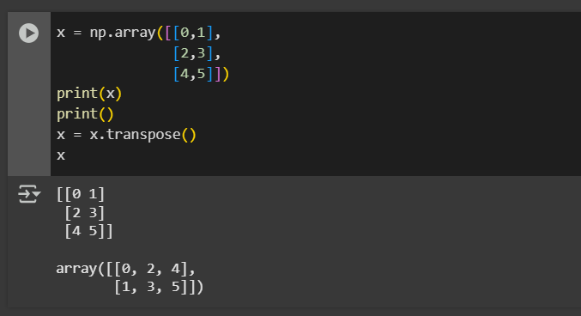
x.shape
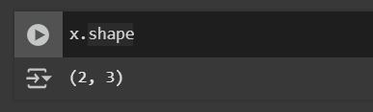

Practical No. 2
import numpy as np
from sklearn.datasets import load_iris
from sklearn.model_selection import train_test_split
from tensorflow.keras.utils import to_categorical
Libraries Used:
1. NumPy (np)
- A library for mathematics and arrays.
- It helps store and process the Iris dataset as numerical arrays.
- Useful for slicing, reshaping, and performing fast calculations.
2. Scikit-learn Datasets (load_iris)
- scikit-learn is a library for machine learning tasks.
- load_iris() gives direct access to the Iris dataset, a popular dataset in machine learning with flower measurements and their species.
3. Scikit-learn Model Selection (train_test_split)
- Helps split data into training and testing sets.
- Training data is used to teach the model, while testing data checks how well the model performs on unseen examples.
4. Scikit-learn Preprocessing (StandardScaler)
- Used for feature scaling (standardization).
- Converts features into values where the mean is 0 and variance is 1.
- This avoids some features dominating others due to larger units (e.g., centimeters vs. millimeters).
5. TensorFlow Keras Utils (to_categorical)
- Converts numeric labels (like 0, 1, 2) into one-hot encoding.
- This representation is better for training neural networks, because each class becomes a vector instead of a single number.

# 1.Load the dataset
iris = load_iris()
X = iris.data
y = iris.target

# 2. One-hot encode the labels
y_encoded = to_categorical(y)

# 3. Split the dataset into training and testing dataset
X_train, X_test, y_train, y_test = train_test_split(X, y_encoded, test_size=0.2, random_state=42)

# 4. Print the shapes to verify
print("X_train shape:", X_train.shape)
print("y_train shape:", y_train.shape)
print("X_test shape:", X_test.shape)
print("y_test shape:", y_test.shape)

#Disp;ay first five rows of features and labels
print("Original Features:\n", X[:5])
print("Original Labels:\n", y[:5])

# 3. Step 3. Feature Scaling (Standardization)
from sklearn.preprocessing import StandardScaler
scaler = StandardScaler()
X_train = scaler.fit_transform(X_train)
X_test = scaler.transform(X_test)

# 4. One-Hot Encoding of Labels
y_encoded = to_categorical(y)
print("\nOne-Hot Encoded Labels:\n", y_encoded[:5])

# 5. Split into training and testing datasets
X_train, X_test, y_train, y_test = train_test_split(X, y_encoded, test_size=0.2, random_state=42)

# 6. Print the final shapes
print("\nTrain/Test Shapes:")
print("X_train shape:", X_train.shape)
print("y_train shape:", y_train.shape)
print("X_test shape:", X_test.shape)
print("y_test shape:", y_test.shape)
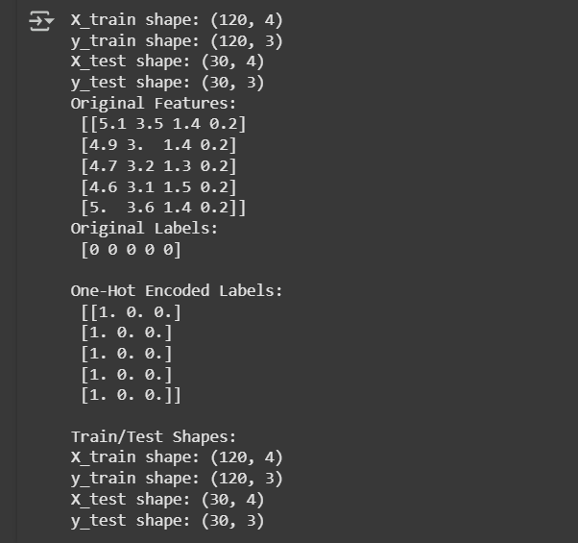

Practical No. 3
1. TensorFlow / Keras (from tensorflow.keras...)
TensorFlow with Keras is the main deep learning framework used here.
- datasets.mnist
  - Provides the MNIST dataset (handwritten digits 0–9).
  - Dataset is already divided into training and testing sets.
- models.Sequential
  - Used to build a sequential neural network model layer by layer.
  - In CNN, layers are added one after another (Conv → Pool → Dense, etc.).
- layers
  - Contains different types of layers for CNN:
    - Conv2D → Convolutional layer, extracts image features (edges, shapes).
    - MaxPooling2D → Reduces image size, keeps only important features.
    - Flatten → Converts 2D feature maps into 1D vector before feeding into Dense layers.
    - Dense → Fully connected layers for classification.
    - Dropout → Prevents overfitting by randomly turning off some neurons during training.
- utils.to_categorical
  - Converts digit labels (0–9) into one-hot encoded form (e.g., 3 → [0,0,0,1,0,0,0,0,0,0]).
2. Matplotlib (import matplotlib.pyplot as plt)
- Used for visualizing images and results.
- In MNIST, it helps display handwritten digit samples (e.g., a “5” image).

import pandas as pd
import numpy as np
from sklearn.preprocessing import StandardScaler, MinMaxScaler, LabelEncoder, OneHotEncoder
from sklearn.model_selection import train_test_split
from sklearn.impute import SimpleImputer

#Simple dataset with mixed data types
data = {
'Age': [25, 46, np.nan, 35, 40],
'Salary': [50000, 60000, 58000, np.nan, 52000],
'Gender': ['Male', 'Female', 'Female', 'Male', 'Female'],
'City': ['New York', 'Los Angeles', 'Chicago', 'Houston', 'San Francisco']
}

df = pd.DataFrame(data)
print("Original Data:\n", df)

# 1 Handling misssing values
imputer = SimpleImputer(strategy='mean')
df['Age'] = imputer.fit_transform(df[['Age']])
df['Salary'] = imputer.fit_transform(df[['Salary']])
print("\nAfter Imputation:\n", df)

# 2 Encoding categorical variables
#Label Encoding (for ordinal or binary categorical)
le = LabelEncoder()
df['Gender'] = le.fit_transform(df['Gender'])

# One-hot encoding (for non-ordinal nominal categorical)
df = pd.get_dummies(df, columns=['City'], drop_first=True)
print("\nAfter Encoding:\n", df)

# 3 Scaling numerical features
# Min-max Scaling
min_max_scaler = MinMaxScaler()
df['Age'] = min_max_scaler.fit_transform(df[['Age']])
df['Salary'] = min_max_scaler.fit_transform(df[['Salary']])
print("\nAfter Feature Scaling:\n", df)

# 4. Splitting data into train and test sets
X = df.drop('Gender', axis=1)
y = df['Gender']
X_train, X_test, y_train, y_test = train_test_split(X, y, test_size=0.2, random_state=42)

print("\nX_train:\n", X_train)
print("\nX_test:\n", X_test)

print("X_train.shape:", X_train.shape)
print("X_test.shape:", X_test.shape)
print("y_train.shape:", y_train.shape)
print("y_test.shape:", y_test.shape)
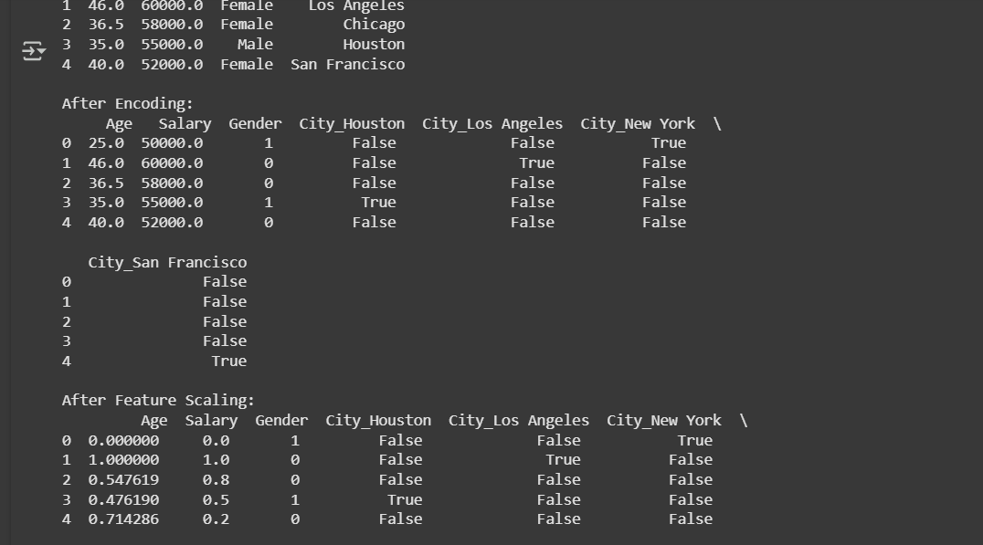
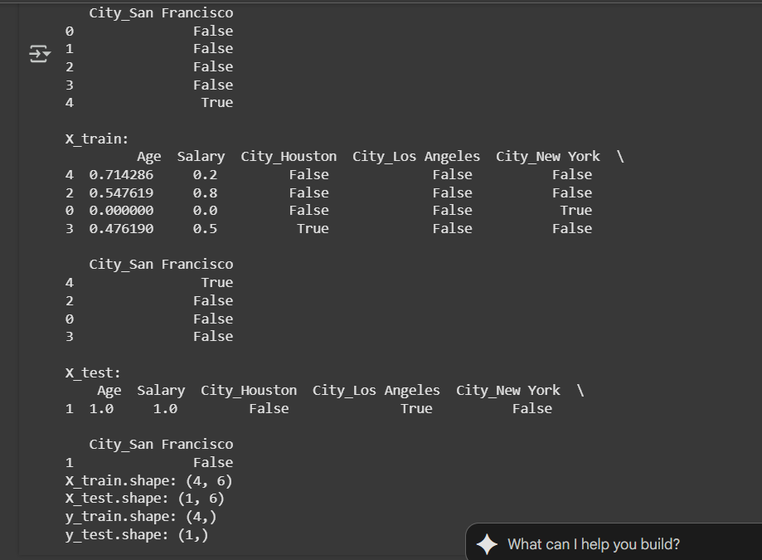
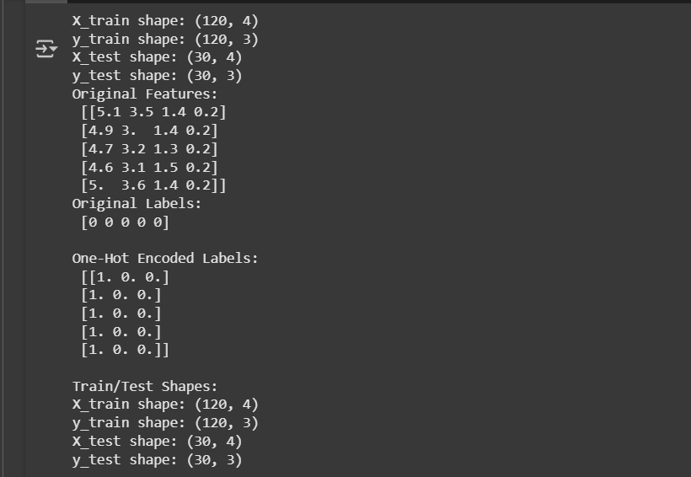

Practical No. 4
Implementation of Artificial Neural Networks –
McCulloch-Pitts neuron with ANDNOT function
def mcp_andnot(x1, x2):
w1, w2 = 1, -1 # weights
theta = 1 # threshold
y_in = w1*x1 + w2*x2

# Step activation function
if y_in >= theta:
return 1
else:
return 0

# Test all input combinations
print("X1 X2 | Y")
for x1 in [0, 1]:
for x2 in [0, 1]:
y = mcp_andnot(x1, x2)
print(f"{x1} {x2} | {y}")

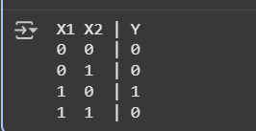

Back propagation Network for XOR function with Binary Input and Output.
import numpy as np
import matplotlib.pyplot as plt

NumPy (Numerical Python) is a powerful library used for scientific computing and numerical operations in Python.
It provides support for multi-dimensional arrays, matrices, and vectorized mathematical operations, which makes it ideal for machine learning and deep learning tasks.
Why it’s used in the code
You’re building a neural network that relies heavily on matrix operations like:
- Multiplying inputs with weights
- Adding biases
- Computing activation functions
- Updating weights using gradient descent
Without NumPy, these operations would have to be written manually using loops — which would be slow and inefficient.
Matplotlib is a data visualization library in Python.
The submodule matplotlib.pyplot works like MATLAB’s plotting system — it helps create graphs and charts easily.
Why it’s used in the code
You use it to visualize how the network learns over time — specifically, how the error decreases during training.
Plotting the error vs. epochs graph helps you see if the network is converging (learning properly).

def sigmoid(x):
return 1/(1+np.exp(-x))

def sigmoid_derivative(x):
return x*(1-x)

errors=[]
x=np.array([[0,0],[0,1],[1,0],[1,1]])
y=np.array([[0],[1],[1],[0]])

np.random.seed(42)
input_layer_neurons=2
hidden_layer_neurons=2
output_layer_neurons=1

hidden_weights=np.random.uniform(size=(input_layer_neurons,hidden_layer_neurons))
hidden_bias=np.random.uniform(size=(1,hidden_layer_neurons))
output_weights=np.random.uniform(size=(hidden_layer_neurons,output_layer_neurons))
output_bias=np.random.uniform(size=(1,output_layer_neurons))

learning_rate=0.1

for epoch in range(10000):
hidden_layer_input=np.dot(x,hidden_weights)+hidden_bias
hidden_layer_output=sigmoid(hidden_layer_input)

final_input=np.dot(hidden_layer_output,output_weights)+output_bias
final_output=sigmoid(final_input)

error=y-final_output
d_output=error*sigmoid_derivative(final_output)
errors.append(np.mean(np.abs(error)))

error_hidden_layer=d_output.dot(output_weights.T)
d_hidden_layer=error_hidden_layer*sigmoid_derivative(hidden_layer_output)

output_weights+=hidden_layer_output.T.dot(d_output)*learning_rate
output_bias+=np.sum(d_output,axis=0,keepdims=True)*learning_rate
hidden_weights+=x.T.dot(d_hidden_layer)*learning_rate
hidden_bias+=np.sum(d_hidden_layer,axis=0,keepdims=True)*learning_rate

print("Final Output: \n",np.round(final_output).astype(int))
plt.plot(errors)
plt.xlabel("Epochs")
plt.ylabel("Error")
plt.title("Error vs Epochs")
plt.grid()
plt.show()
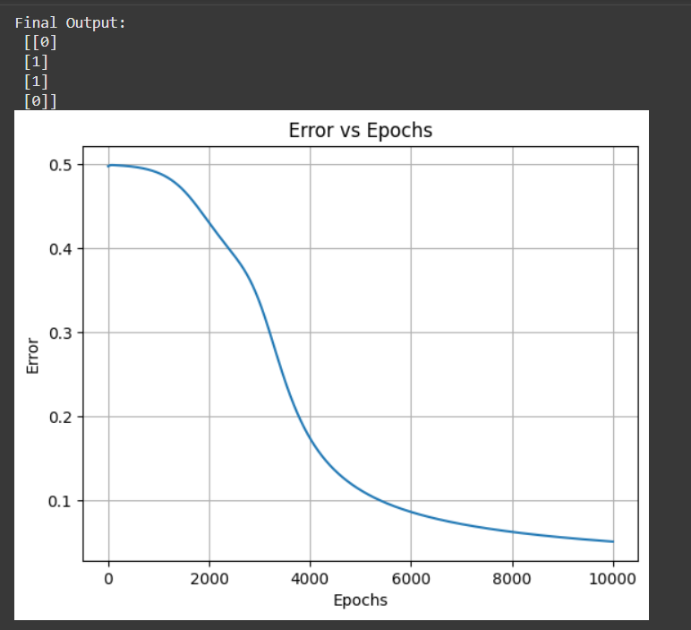

Assignment
Explain McCulloch-Pitts neuron with ANDNOT
What is the McCulloch–Pitts Neuron?
The McCulloch–Pitts neuron (proposed in 1943) is the simplest mathematical model of a biological neuron.
It’s a binary threshold unit, meaning it produces either 0 (inactive) or 1 (active) output.
It works in three basic steps:
- Takes multiple binary inputs (0 or 1).
- Applies weights to each input to decide their importance.
- Sums all weighted inputs and compares the total with a threshold (θ).
  - If the total ≥ threshold → output = 1
  - Otherwise → output = 0
Mathematical Representation
Let inputs be x1,x2,x3,...x_1, x_2, x_3, ...x1​,x2​,x3​,...
and corresponding weights be w1,w2,w3,...w_1, w_2, w_3, ...w1​,w2​,w3​,...
Then:
y=f(∑wixi)y = f\left(\sum w_i x_i\right)y=f(∑wi​xi​)
Where fff is a threshold function defined as:
f(net)={1,if net≥θ0,if net<θf(net) = \begin{cases} 1, & \text{if } net \ge \theta \\ 0, & \text{if } net < \theta \end{cases}f(net)={1,0,​if net≥θif net<θ​
What is AND-NOT?
The AND-NOT logic means:
Output=A AND (NOT B)\text{Output} = A \text{ AND (NOT B)}Output=A AND (NOT B)
The truth table:
A | B | Output (A AND NOT B)
0 | 0 | 0
0 | 1 | 0
1 | 0 | 1
1 | 1 | 0

Representing AND-NOT using McCulloch–Pitts Neuron
We’ll use two inputs:
- x1=Ax_1 = Ax1​=A
- x2=Bx_2 = Bx2​=B
We want the neuron to fire (output 1) only when A = 1 and B = 0.
Assign weights and threshold
Let:
- Weight for AAA = +1
- Weight for BBB = –1 (since we want NOT B)
- Threshold θ=1θ = 1θ=1
So the net input = (1×A)+(−1×B)(1 × A) + (-1 × B)(1×A)+(−1×B)
Now check each case:
A | B | Net Input | Output (≥1 → 1 else 0)
0 | 0 | 0 | 0
0 | 1 | -1 | 0
1 | 0 | 1 | 1
1 | 1 | 0 | 0

Practical No. 5
Implementation of Regularization Techniques-Dataset Augmentation, Early Stopping, Dropout.
import tensorflow as tf
from tensorflow.keras.datasets import cifar10
from tensorflow.keras.preprocessing.image import ImageDataGenerator
from tensorflow.keras.models import Sequential
from tensorflow.keras.layers import Dense, Dropout, Activation, Flatten
from tensorflow.keras.layers import Conv2D, MaxPooling2D
from tensorflow.keras.callbacks import EarlyStopping
from tensorflow.keras.utils import to_categorical
(x_train, y_train), (x_test, y_test) = cifar10.load_data()
x_train=x_train.astype('float32')
x_test=x_test.astype('float32')
x_train/=255.0
x_test/=255.0
y_train = to_categorical(y_train, 10)
y_test = to_categorical(y_test, 10)
datagen= ImageDataGenerator(
rotation_range=15,
width_shift_range=0.1,
height_shift_range=0.1,
horizontal_flip=True,
)
datagen.fit(x_train)
model=Sequential([
Conv2D(32, (3,3),activation='relu', input_shape=(32,32,3)),
MaxPooling2D(pool_size=(2,2)),
Dropout(0.25),
Conv2D(64, (3,3),activation='relu'),
MaxPooling2D(pool_size=(2,2)),
Dropout(0.25),
Flatten(),
Dense(512, activation='relu'),
Dropout(0.5),
Dense(10, activation='softmax')
])
model.compile(optimizer='adam',loss='categorical_crossentropy',metrics=['accuracy'])
early_stop=EarlyStopping(monitor='val_loss',patience=5,restore_best_weights=True)
history=model.fit(datagen.flow(x_train,y_train,batch_size=64),epochs=50,validation_data=(x_test,y_test),callbacks=[early_stop])
test_loss, test_acc=model.evaluate(x_test,y_test,verbose=2)
print(f'Test Accuracy:{test_acc:.4f}')

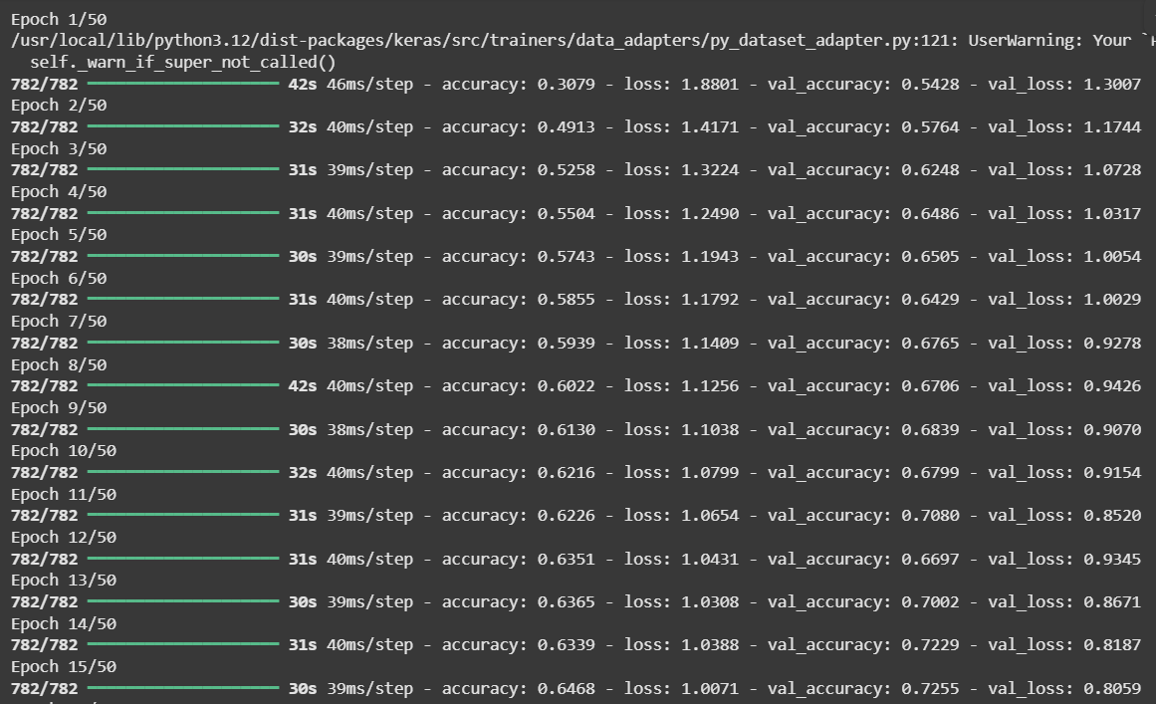
import pandas as pd
import numpy as np
from sklearn.preprocessing import StandardScaler,MinMaxScaler,LabelEncoder,OneHotEncoder
from sklearn.model_selection import train_test_split
from sklearn.impute import SimpleImputer
data={'Age':[25,30,np.nan,35,40],
'Salary':[50000,60000,58000,np.nan,52000],
'Gender':['Male','Female','Female','Male','Male'],
'City':['Mumbai','Pune','Delhi','Mumbai','Pune']}
df=pd.DataFrame(data)
print('Orignal data:\n',df)
imputer=SimpleImputer(strategy='mean')
df[['Age','Salary']]=imputer.fit_transform(df[['Age','Salary']])
print('Data after imputing missing values:\n',df)
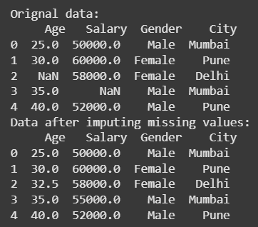
le=LabelEncoder()
df['Gender_encoded']=le.fit_transform(df['Gender'])
df=pd.get_dummies(df,columns=['City'],drop_first=True)
print('Data after encoding:\n',df)
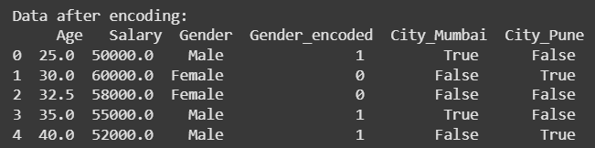
min_max=MinMaxScaler()
df[['Age','Salary']]=min_max.fit_transform(df[['Age','Salary']])
print('Data after scaling:\n',df)
scaler=StandardScaler()
df[['Age','Salary']]=scaler.fit_transform(df[['Age','Salary']])
print('Data after scaling:\n',df)
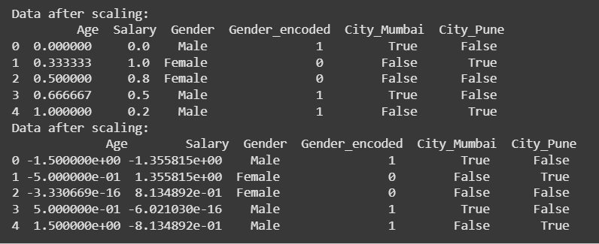
x=df.drop(['Gender'],axis=1)
y=df['Gender']
x_train,x_test,y_train,y_test=train_test_split(x,y,test_size=0.2,random_state=42)
print('Training data:\n',x_train)
print('Testing data:\n',x_test)
print('X_train shape',x_train.shape)
print('X_test shape',x_test.shape)
print('Y_train shape',y_train.shape)
print('Y_test shape',y_test.shape)
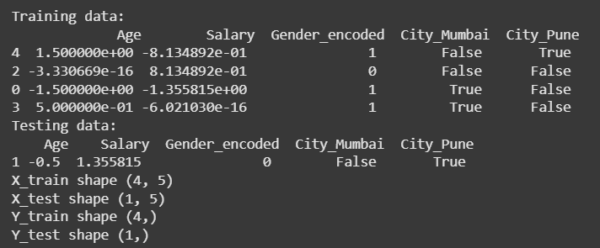
import pandas as pd
from sklearn.datasets import load_iris
from sklearn.model_selection import train_test_split
iris=load_iris()
x=iris.data
y=iris.target
print(x[:5])
print(y[:5])
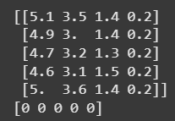
scaler=StandardScaler()
x_scaled=scaler.fit_transform(x)
print("Scaled x using Standard scaler:",x_scaled[:5])
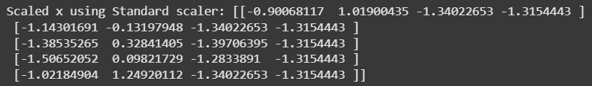
from tensorflow.keras.utils import to_categorical
y_encoded=to_categorical(y)
print("Encoded y using on hot encoder:",y_encoded[:5])
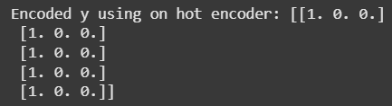
x_train,x_test,y_train,y_test=train_test_split(x_scaled,y_encoded,test_size=0.2,random_state=42)
print("X_train shape:",x_train.shape)
print("X_test shape:",x_test.shape)
print("Y_train shape:",y_train.shape)
print("Y_test shape:",y_test.shape)
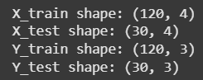

Assignment
Compare different regularization techniques in deep learning

Technique | Working Principle | Mathematical Idea | Effect on Model | Advantages | Disadvantages / Limitations
L1 Regularization (Lasso) | Adds a penalty equal to the absolute value of weights to the loss function. | ( L_{new} = L_{original} + \lambda \sum | w_i | ) | Encourages sparse weights — some weights become 0 → acts like feature selection.
L2 Regularization (Ridge) | Adds a penalty equal to the square of weights. | ( L_{new} = L_{original} + \lambda \sum w_i^2 ) | Keeps all weights small but non-zero → distributes learning. | Prevents overfitting, smoother optimization. | Doesn’t perform feature selection.
Elastic Net Regularization | Combines L1 and L2 penalties. | ( L_{new} = L_{original} + \lambda_1 \sum | w_i | + \lambda_2 \sum w_i^2 ) | Balances between sparsity and smoothness.
Dropout | Randomly drops (turns off) some neurons during training with probability p. | During training: randomly set some activations = 0 | Prevents co-adaptation of neurons; forces the network to learn redundant representations. | Very effective for large neural nets; easy to implement. | Slower training; must adjust learning rate and batch normalization.
Early Stopping | Stop training when validation loss starts increasing (overfitting begins). | Monitors validation loss each epoch. | Stops model before it starts memorizing data. | Simple and effective without altering the loss function. | Requires proper validation split; may stop slightly early.
Data Augmentation | Increase dataset size artificially (rotate, crop, flip, scale, noise). | Modifies training data, not model. | Makes model invariant to minor variations. | Great for image/audio/text models; reduces overfitting. | Doesn’t help if data variety is already high.
Batch Normalization (BN) | Normalizes layer inputs to have mean 0 and variance 1. | Normalizes activations within mini-batches. | Adds stability; acts as implicit regularization. | Improves convergence, allows higher learning rate. | Adds computation overhead; behaves differently during inference.
Weight Decay | Equivalent to L2 regularization applied to gradient updates. | ( w = w - \eta(\frac{dL}{dw} + \lambda w) ) | Prevents weights from growing large. | Common in optimizers (e.g., AdamW, SGD). | Needs tuning of λ; may slow learning.
Noise Injection | Adds small random noise to inputs or weights during training. | ( x' = x + \epsilon ) | Improves model robustness to input variations. | Simulates real-world noise; boosts generalization. | Can slow convergence if noise is too high.
Practical No. 6
Implementation and analysis of Deep Neural network algorithm:
Convolutional neural network (CNN): Object identification and classification,Image recognition.
import tensorflow as tf
TensorFlow is an open-source deep learning framework developed by Google.
It allows you to build, train, and deploy neural networks efficiently using high-level APIs.
🔹 Why it’s used:
TensorFlow provides tools to:
- Build Convolutional Neural Networks (CNNs)
- Train models on GPUs/TPUs
- Evaluate, save, and load model
from tensorflow.keras.datasets import cifar10
Keras (submodule of TensorFlow)
We’ve used Keras via TensorFlow (as tensorflow.keras), which is a high-level API to simplify deep learning model creation.
Let’s break down the parts us imported:
Module / Function | Purpose | Explanation
from tensorflow.keras.datasets import cifar10 | Dataset | Loads the CIFAR-10 dataset — a collection of 60,000 color images (32×32 pixels) in 10 classes such as airplane, cat, ship, etc.
from tensorflow.keras.models import Sequential, load_model | Model handling | Sequential helps build CNN layer-by-layer.  load_model loads a previously saved .h5 model file.
from tensorflow.keras.layers import Conv2D, MaxPooling2D, Flatten, Dense, Dropout | Layers | Provides the building blocks of a CNN:  - Conv2D: convolution filters to extract features.  - MaxPooling2D: reduces spatial size (downsampling).  - Flatten: converts 2D feature maps into 1D vector.  - Dense: fully connected layers for classification.  - Dropout: prevents overfitting by randomly turning off neurons.
from tensorflow.keras.utils import to_categorical | Label encoding | Converts numeric labels (0–9) into one-hot encoded vectors like [0,0,1,0,0,0,0,0,0,0] — required for multi-class classification.
from tensorflow.keras.preprocessing import image | Image processing | Loads, resizes, and converts new images for model prediction.

from tensorflow.keras.models import Sequential, load_model
from tensorflow.keras.layers import Conv2D, MaxPooling2D, Flatten, Dense, Dropout
from tensorflow.keras.utils import to_categorical
import numpy as np
NumPy (Numerical Python) is a library for handling large multi-dimensional arrays and performing mathematical operations efficiently.
🔹 Why it’s used:
In your code, NumPy is used to:
- Handle image arrays (img_array = np.expand_dims(img_array, axis=0))
- Perform matrix operations for preprocessing
- Manage numeric computations during training and predictions
import matplotlib.pyplot as plt
Matplotlib is a visualization library used for plotting data, graphs, and images.
🔹 Why it’s used:
We use it to display images and show the predicted class visually.
from tensorflow.keras.preprocessing import image
from google.colab import files
A Colab-specific utility that allows users to upload and download files between our local computer and the Colab environment.
🔹 Why it’s used:
We use it to upload custom images for testing your trained model.
Function | Purpose
files.upload() | Opens a file chooser in Colab to upload image(s) from our computer.
uploaded.keys() | Returns a list of uploaded file names so we can loop through them for prediction.

#step 2: Load ciphar-10 dataset
(x_train, y_train), (x_test, y_test) = cifar10.load_data()

#step 3: Normalize (0-1 scale)
x_train, x_test = x_train / 255.0, x_test / 255.0

#One-hot encode labels
y_train = to_categorical(y_train, 10)
y_test = to_categorical(y_test, 10)

#CIPHAR-10 class labels
class_labels = ['airplane', 'automobile', 'bird', 'cat', 'deer', 'dog', 'frog', 'horse', 'ship', 'truck']

#step 3: Define CNN Model
model = Sequential([
Conv2D(32, (3, 3), activation='relu', input_shape=(32, 32, 3)),
MaxPooling2D((2, 2)),
Conv2D(64, (3, 3), activation='relu'),
MaxPooling2D((2, 2)),
Flatten(),
Dense(128, activation='relu'),
Dropout(0.5),
Dense(10, activation='softmax')
])

#Step 4: Compile Model
model.compile(optimizer='adam', loss='categorical_crossentropy', metrics=['accuracy'])

#Step 5: Train Model
history = model.fit(x_train, y_train, epochs=10, batch_size=64, validation_split=0.2, verbose=1)

#Step 6: Evaluate Model
test_loss, test_acc = model.evaluate(x_test, y_test, verbose=1)
print(f"\nTest accuracy: {test_acc*100:.2f}%")

#Step 7: Save Model
model.save("cnn_cifar10_model.h5")
print("Model saved as cnn_ciphar10.h5")

#Step 8: Load saved model(to ensure it is available)
model = load_model("cnn_cifar10_model.h5")

#Step 9: Upload and Predict
uploaded = files.upload()
for filename in uploaded.keys():
#load image and resize to 32x32 (same as CIPHAR-10)
img = image.load_img(filename, target_size=(32, 32))
img_array = image.img_to_array(img)
img_array = np.expand_dims(img_array, axis=0)
img_array /= 255.0
#Predict class
predictions = model.predict(img_array)
predicted_class = class_labels[np.argmax(predictions)]
#show image + prediction
plt.imshow(img)
plt.axis('off')
plt.title(f"Predicted class: {predicted_class}")
plt.show()
print(f"Predicted class: {predicted_class}")
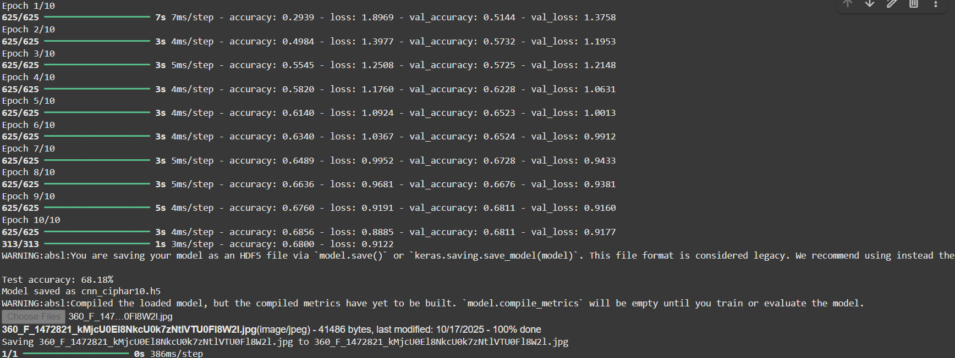
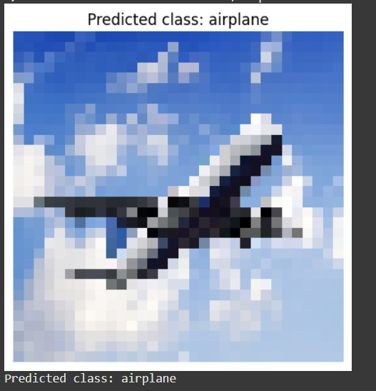

Assignment Question: Explain step by step Implementation and Analysis of CNN for Object Identification and Image Recognition
CNN for Object Identification — Short Step-by-Step Implementation & Analysis
- Define task & metrics
  - Decide classification vs detection.
  - Pick metrics: accuracy/F1 for classification, mAP/IoU for detection.
- Prepare dataset
  - Collect → clean → split (train/val/test, e.g. 70/15/15).
  - Ensure class balance and hold out a test set.
- Preprocess & augment
  - Resize (e.g. 224×224 or 32×32), normalize pixels (0–1 or mean/std).
  - Apply augmentations (flip, crop, rotate, color jitter, CutMix) on train only.
- Choose architecture
  - Small: LeNet; Classic: VGG; Robust: ResNet; Mobile: MobileNet/EfficientNet.
  - Use ImageNet pretrained backbone when possible.
- Build model
  - Stack: Conv → Activation → Pool → (repeat) → Flatten/GlobalPool → Dense → Softmax.
  - Add Dropout/BatchNorm where needed.
- Set loss & optimizer
  - Loss: Cross-Entropy for classification; combined losses for detection.
  - Optimizer: SGD+momentum (robust) or Adam (faster). Use weight decay.
- Choose training strategy
  - Learning rate schedule (Step, Cosine, or ReduceLROnPlateau). Warmup if large batch.
  - Batch size per GPU memory. Mixed precision for speed.
- Train & validate
  - Monitor train/val loss and metrics each epoch.
  - Save best checkpoint (based on val metric). Use early stopping if needed.
- Analyze & diagnose
  - Plot curves (loss/accuracy). Check overfit/underfit.
  - Confusion matrix, per-class precision/recall. Visualize failure cases.
- Interpretability checks
- Use Grad-CAM / saliency to confirm the model focuses on the object, not background cues.
- Final evaluation
- Run on held-out test set; report metrics and per-class breakdown.
- Perform OOD or domain-shift checks.
- Optimize for deployment
- Quantize / prune / distill for edge. Export to ONNX/TFLite/TensorRT. Measure latency & memory.
- Quick troubleshooting tips
- Overfitting → more augmentation, weight decay, dropout, or smaller model.
- Underfitting → larger model, less regularization, longer training.
- Class imbalance → class weights, focal loss, oversampling.
- Checklist before claiming success
- Stable val metrics, sensible visualizations (Grad-CAM), test matches val, and inference meets latency constraints.

Practical No. 7
Implementation and analysis of Deep Neural network algorithm:
Recurrent neural network (RNN) - Character recognition and web traffic Image classification.
import os,random,math,time
import numpy as np
Numerical / array library
- numpy as np — fundamental package for numerical arrays and operations. Used for seeding, array manipulation, type conversions, normalization, and metric computations.
import torch
PyTorch (deep learning)
- torch — core PyTorch library (tensors, device management). You use it to detect GPU (torch.cuda.is_available()), set seeds, and control backend flags (cudnn.deterministic, benchmark).
- torch.nn as nn — neural network building blocks:
  - nn.LSTM — the recurrent layer used to treat image rows as sequences.
  - nn.Linear — fully connected layer for classification head.
  - nn.Module — base class for models.
  - nn.CrossEntropyLoss() — the criterion (loss) for multi-class classification.
- torch.optim as optim — optimizers:
  - optim.AdamW — Adam variant with decoupled weight decay, used for training parameters.
- torch.utils.data
  - DataLoader — batches and shuffles dataset, handles multi-worker loading and pin_memory for GPU.
  - Subset — (imported though not used here) useful for creating smaller dataset splits.
PyTorch provides the whole training stack (model, loss, optimizer, device handling).

import torch.nn as nn
import torch.optim as optim
from torch.utils.data import DataLoader,Subset
from torchvision import datasets,transforms
Torchvision (datasets & transforms)
- torchvision.datasets — standard datasets:
  - MNIST, EMNIST — readily available image datasets; downloaded and wrapped as PyTorch datasets.
- torchvision.transforms — preprocessing utilities:
  - transforms.ToTensor() — converts PIL images / numpy arrays to PyTorch tensors scaled [0,1].
  - transforms.Normalize(mean, std) — normalizes channels to zero mean/unit variance (important for stable training).
Transforms form the input pipeline for training and evaluation.

import matplotlib.pyplot as plt
Plotting & visualization
- matplotlib.pyplot as plt — plotting library used to display the confusion matrix and other visual diagnostics (images, loss curves, etc.).
from sklearn.metrics import accuracy_score,classification_report,confusion_matrix
Evaluation utilities (scikit-learn)
- sklearn.metrics
  - accuracy_score — computes overall accuracy.
  - classification_report — per-class precision/recall/F1 summary.
  - confusion_matrix — builds the confusion matrix for detailed error analysis.
These give standard, easy-to-read evaluation metrics.

import itertools
SEED=42
random.seed(SEED)
np.random.seed(SEED)
torch.manual_seed(SEED)
torch.cuda.manual_seed_all(SEED)

torch.backends.cudnn.deterministic=True
torch.backends.cudnn.benchmark=False
device=torch.device("cuda" if torch.cuda.is_available() else "cpu")
device

def plot_confusion_matrix(cm,classes,normalize=False,title="Confusion Matrix"):
if normalize:
cm=cm.astype("float")/cm.sum(axis=1)[:,np.newaxis]
plt.figure()
plt.imshow(cm,interpolation="nearest")
plt.title(title)
tick_marks=np.arange(len(classes))
plt.xticks(tick_marks,classes,rotation=45)
plt.yticks(tick_marks,classes)

fmt=".2f" if normalize else "d"
thresh=cm.max()/2
for i,j in itertools.product(range(cm.shape[0]),range(cm.shape[1])):
plt.text(j,i,format(cm[i,j],fmt),horizontalalignment="center",color="white" if cm[i,j]>thresh else "black")
plt.tight_layout()
plt.ylabel("True Label")
plt.xlabel("Predicted Label")
plt.show()

use_emnist=False
batch_size=128
transform=transforms.Compose([
transforms.ToTensor(),
transforms.Normalize((0.1307,),(0.3081,))
])
if use_emnist:
train_dataset=datasets.EMNIST(root="./data",split="letters",download=True,train=True,transform=transform)
test_dataset=datasets.EMNIST(root="./data",split="letters",download=True,train=False,transform=transform)
num_classes=26
class_names=[chr(ord('A')+i)for i in range(26)]
else:
train_dataset=datasets.MNIST(root="./data",download=True,train=True,transform=transform)
test_dataset=datasets.MNIST(root="./data",download=True,train=False,transform=transform)
num_classes=10
class_names=[str(i) for i in range(10)]

train_loader=DataLoader(train_dataset,batch_size=batch_size,shuffle=True,num_workers=2,pin_memory=True)
test_loader=DataLoader(test_dataset,batch_size=batch_size,shuffle=False,num_workers=2,pin_memory=True)
len(train_dataset),len(test_dataset),num_classes,class_names[:5]

#@title define lstm classifier for images as sequences
class ImageRNN(nn.Module):
def __init__(self,input_size=28,hidden_size=128,num_layers=2,num_classes=10,bidirectional=False,dropout=0.1):
super().__init__()
self.hidden_size=hidden_size
self.num_layers=num_layers
self.bidirectional=bidirectional
self.lstm=nn.LSTM(input_size=input_size,hidden_size=hidden_size,num_layers=num_layers,batch_first=True,bidirectional=bidirectional,dropout=dropout if num_layers>1 else 0.0)
out_dim=hidden_size*(2 if bidirectional else 1)
self.fc=nn.Linear(out_dim,num_classes)
def forward(self,x):
B,C,H,W=x.size()
x=x.view(B, H, W) # Reshape to (batch_size, sequence_length, input_size)
output, (hn,cn) = self.lstm(x)
last = output[:, -1, :]
out = self.fc(last)
return out

model = ImageRNN(input_size = 28,hidden_size=128,num_layers=2,num_classes=num_classes,bidirectional=True).to(device)
criterion=nn.CrossEntropyLoss()
optimizer=optim.AdamW(model.parameters(),lr=0.001,weight_decay=1e-4)
scheduler=optim.lr_scheduler.ReduceLROnPlateau(optimizer,mode="min",patience=5,factor=0.5)
model
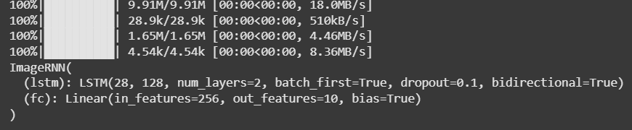
def train_one_epoch(model, loader, optimizer, criterion):
model.train()

total_loss, total_correct, total = 0.0, 0, 0

for x, y in loader:

x, y = x.to(device), y.to(device)

if x.shape[-1] == 28 and x.shape[-2] == 28 and model.fc.out_features == 26 and y.min().item() == 1:

y = y - 1

optimizer.zero_grad()

logits = model(x)

loss = criterion(logits, y)

loss.backward()

optimizer.step()

preds = logits.argmax(dim=1)

total += y.size(0)

total_loss += loss.item() * y.size(0)

total_correct += (preds == y).sum().item()

return total_loss / total, total_correct / total

@torch.no_grad()

def evaluate(model, loader, criterion):

model.eval()

total_loss, total_correct, total = 0.0, 0, 0

all_preds, all_targets = [], []

for x, y in loader:

x, y = x.to(device), y.to(device)

if x.shape[-1] == 28 and x.shape[-2] == 28 and model.fc.out_features == 26 and y.min().item() == 1:

y = y - 1

logits = model(x)

loss = criterion(logits, y)

preds = logits.argmax(dim=1)

total += y.size(0)

total_loss += loss.item() * y.size(0)

total_correct += (preds == y).sum().item()

all_preds.append(preds.cpu().numpy())

all_targets.append(y.cpu().numpy())

all_preds = np.concatenate(all_preds)

all_targets = np.concatenate(all_targets)

return total_loss / total, total_correct / total, all_preds, all_targets
#@title Train (A): LSTM for Character Recognition

def train_one_epoch(model, loader, optimizer, criterion):
model.train()

total_loss, total_correct, total = 0.0, 0, 0

for x, y in loader:

x, y = x.to(device), y.to(device)

if x.shape[-1] == 28 and x.shape[-2] == 28 and model.fc.out_features == 26 and y.min().item() == 1:

y = y - 1

optimizer.zero_grad()

logits = model(x)

loss = criterion(logits, y)

loss.backward()

optimizer.step()

preds = logits.argmax(dim=1)

total += y.size(0)

total_loss += loss.item() * y.size(0)

total_correct += (preds == y).sum().item()

return total_loss / total, total_correct / total

@torch.no_grad()

def evaluate(model, loader, criterion):

model.eval()

total_loss, total_correct, total = 0.0, 0, 0

all_preds, all_targets = [], []

for x, y in loader:

x, y = x.to(device), y.to(device)

if x.shape[-1] == 28 and x.shape[-2] == 28 and model.fc.out_features == 26 and y.min().item() == 1:

y = y - 1

logits = model(x)

loss = criterion(logits, y)

preds = logits.argmax(dim=1)

total += y.size(0)

total_loss += loss.item() * y.size(0)

total_correct += (preds == y).sum().item()

all_preds.append(preds.cpu().numpy())

all_targets.append(y.cpu().numpy())

all_preds = np.concatenate(all_preds)

all_targets = np.concatenate(all_targets)

return total_loss / total, total_correct / total, all_preds, all_targets

epochs = 10 #@param {type:"integer"}

train_losses, test_losses, test_accs = [], [], []

for epoch in range(1, epochs+1):
tr_loss, tr_acc = train_one_epoch(model, train_loader, optimizer, criterion)
te_loss, te_acc, te_preds, te_targets = evaluate(model, test_loader, criterion)
scheduler.step(te_loss)

train_losses.append(tr_loss)
test_losses.append(te_loss)
test_accs.append(te_acc)

print(f"Epoch {epoch:02d} | Train Loss {tr_loss:.4f} Acc {tr_acc:.4f} | Test Loss {te_loss:.4f} Acc {te_acc:.4f}")

plt.figure()
plt.plot(train_losses, label="Train Loss")
plt.plot(test_losses, label="Test Loss")
plt.legend()
plt.xlabel("Epoch")
plt.ylabel("Loss")
plt.title("Character Recognition — Loss Curves")
plt.show()

plt.figure()
plt.plot(test_accs, label="Test Accuracy")
plt.legend()
plt.xlabel("Epoch")
plt.ylabel("Accuracy")
plt.title("Character Recognition — Accuracy Curve")
plt.show()

cm = confusion_matrix(te_targets, te_preds)
plot_confusion_matrix(cm, class_names, normalize=False, title="Confusion Matrix (Character Recognition)")
print(classification_report(te_targets, te_preds, target_names=class_names))
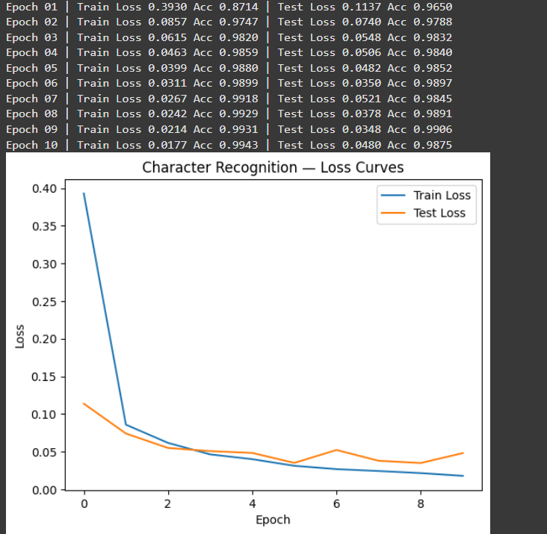
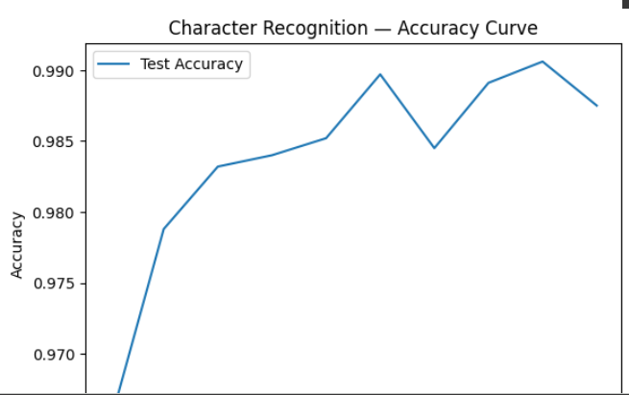
#@title Data: CIFAR-10 -> Vehicle vs. Non-vehicle
batch_size_cifar=128 #@param{type:"integer"}

transform_cifar=transforms.Compose([
transforms.Grayscale(num_output_channels=1),
transforms.ToTensor(),
transforms.Normalize((0.5,),(0.5,))
])

train_cifar=datasets.CIFAR10(root='./data',train=True,download=True,transform=transform_cifar)
test_cifar=datasets.CIFAR10(root='./data',train=False,download=True,transform=transform_cifar)

vehicle_classes={1,9}

def map_vehicle(label):
return 1 if label in vehicle_classes else 0
class MappedCIFAR(torch.utils.data.Dataset):
def __init__(self,dataset):
self.base = dataset
def __len__(self):
return len(self.base)
def __getitem__(self,idx):
x,y=self.base[idx]
return x, torch.tensor(map_vehicle(y)).long()

train_cifar_m = MappedCIFAR(train_cifar)
test_cifar_m = MappedCIFAR(test_cifar)

train_loader_cifar=DataLoader(train_cifar_m,batch_size=batch_size_cifar,shuffle=True,num_workers=2,pin_memory=True)
test_loader_cifar=DataLoader(test_cifar_m,batch_size=batch_size_cifar,shuffle=False,num_workers=2,pin_memory=True)

len(train_cifar_m),len(test_cifar_m)
#@title Define Bidirectional LSTM for CIFAR rows
class BiLSTMClassifier(nn.Module):
def __init__(self,input_size=32,hidden_size=128,num_layers=2,num_classes=10,bidirectional=False,dropout=0.1):
super().__init__()
self.hidden_size=hidden_size
self.num_layers=num_layers
self.bidirectional=bidirectional
self.lstm=nn.LSTM(input_size=input_size,hidden_size=hidden_size,num_layers=num_layers,batch_first=True,bidirectional=bidirectional,dropout=dropout if num_layers>1 else 0.0)
out_dim=hidden_size*(2 if bidirectional else 1)
self.fc=nn.Linear(out_dim,num_classes)
def forward(self,x):
B,C,H,W=x.size()
x=x.view(B, H, W) # Reshape to (batch_size, sequence_length, input_size)
output, (hn,cn) = self.lstm(x)
last = output[:, -1, :]
out = self.fc(last)
return out

model = BiLSTMClassifier(input_size = 32,hidden_size=128,num_layers=2,num_classes=2,bidirectional=True).to(device) # num_classes should be 2 for vehicle vs non-vehicle
criterion=nn.CrossEntropyLoss()
optimizer=optim.AdamW(model.parameters(),lr=0.001,weight_decay=1e-4)
scheduler=optim.lr_scheduler.ReduceLROnPlateau(optimizer,mode="min",patience=5,factor=0.5)
model
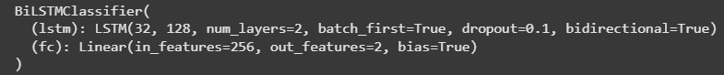

Assignment Question: How RNN is useful in character recognition?
An RNN (Recurrent Neural Network) is a type of neural network that can remember information from previous inputs using its internal state (memory).
Unlike regular feedforward networks, RNNs process sequential data — data where order or context matters.
Why use RNNs for character recognition?
Character recognition can be seen as a sequence learning problem, depending on the context:
Type | Example | Sequence Nature
Offline Handwritten Character | A scanned handwritten letter (like “A”) | Sequence of pixels/rows
Online Handwriting | Stylus writing captured over time | Sequence of pen strokes
Text Recognition (OCR) | Whole word or line in handwriting or image | Sequence of characters
In all these cases, data can be represented as a temporal or spatial sequence, which RNNs handle very well.
How RNN helps
RNNs can learn dependencies between sequential elements — like strokes, curves, or neighboring pixels — which helps identify the character shape.
Example:
Imagine a 28×28 handwritten image (like MNIST digit).
You can feed each row (28 pixels) to the RNN one by one as a time step:
Row1 → Row2 → Row3 → ... → Row28
At each step, the RNN updates its hidden state to “remember” previous row information.
After reading all rows, the final state contains a summary of the whole character’s shape, which is then used for classification.
Advantages of using RNN in character recognition
Feature | Explanation
Sequence learning | Captures sequential relationships between image rows or pen strokes.
Context awareness | Understands how early strokes affect later parts of the character.
Robustness | Handles variations in writing style, spacing, and speed (for online input).
Dimensional reduction | Converts 2D spatial info into 1D temporal info, reducing parameters.
Versatility | Can be extended to recognize sequences of characters (whole words).

RNN variants used in practice
Because basic RNNs suffer from vanishing gradients, we often use improved versions:
Type | Why used
LSTM (Long Short-Term Memory) | Remembers long-term dependencies using gates.
GRU (Gated Recurrent Unit) | Simplified version of LSTM, faster and efficient.
Bi-directional RNNs | Reads sequence in both forward and backward directions for more context.
These are excellent for handwriting recognition, OCR, and text line recognition.

Practical No. 8: LSTM Network: Sentiment analysis using LSTM
# Sentiment Analysis using LSTM in Keras/TensorFlow
# Step 1: Import required libraries
import numpy as np
NumPy = Numerical Python. It provides fast operations on large multi-dimensional arrays and matrices.
🔹 Why it’s used here:
- Handles numeric arrays and tensor-like data.
- Performs mathematical operations (e.g., padding, reshaping, indexing).
- Used when preparing model input data or predictions.
✅ Example:
np.argmax(preds, axis=1) → finds the class with the highest probability.
import matplotlib.pyplot as plt
Matplotlib is a popular Python library for data visualization — plotting graphs and charts.
🔹 Why it’s used here:
To visualize model training progress — e.g., how accuracy and loss change over epochs.
✅ Example:
- plt.plot(history.history['accuracy']) → plots training accuracy over time.
- plt.title("Training and Validation Accuracy") → adds a title to the chart.
from tensorflow.keras.datasets import imdb
TensorFlow is an open-source deep learning framework by Google.
Keras is its high-level API that simplifies building and training neural networks.
We use Keras (inside TensorFlow) to handle:
- Dataset loading
- Preprocessing
- Model building (Sequential API)
- Training, evaluation, and prediction

from tensorflow.keras.preprocessing.sequence import pad_sequences
from tensorflow.keras.models import Sequential
from tensorflow.keras.layers import Embedding, LSTM, Dense, Dropout
# Step 2: Load IMDB dataset
# num_words=10000 means we keep only the top 10,000 most frequent words
max_features = 10000
max_len = 200 # Maximum length of a review
(x_train, y_train), (x_test, y_test) = imdb.load_data(num_words=max_features)
print("Training data shape:", x_train.shape, "Labels shape:", y_train.shape)
print("Test data shape:", x_test.shape, "Labels shape:", y_test.shape)
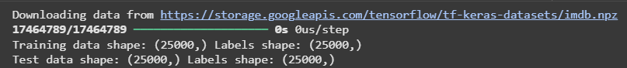
# Step 3: Pad sequences (make all reviews the same length)
x_train = pad_sequences(x_train, maxlen=max_len)
x_test = pad_sequences(x_test, maxlen=max_len)
print("After padding:")
print("Training data shape:", x_train.shape)
print("Test data shape:", x_test.shape)
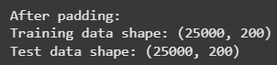
# Step 4: Build LSTM Model
model = Sequential()
model.add(Embedding(max_features, 128, input_length=max_len)) # Embedding layer
model.add(LSTM(128, dropout=0.2, recurrent_dropout=0.2)) # LSTM layer
model.add(Dense(1, activation='sigmoid')) # Output layer
# Step 5: Compile Model
model.compile(loss='binary_crossentropy',
optimizer='adam',
metrics=['accuracy'])
print(model.summary())
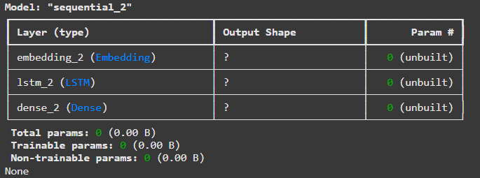
# Step 6: Train the Model
history = model.fit(x_train, y_train, batch_size=64, epochs=5, validation_data=(x_test, y_test))
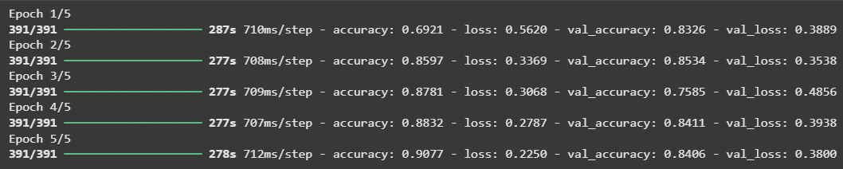
# Step 7: Evaluate Model
score, acc = model.evaluate(x_test, y_test, batch_size=64)
print("Test loss:", score)
print("Test accuracy:", acc)
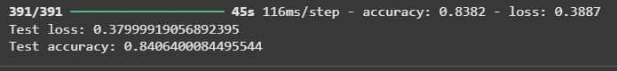
# Step 8: Plot Training History
plt.plot(history.history['accuracy'], label='Train Accuracy')
plt.plot(history.history['val_accuracy'], label='Validation Accuracy')
plt.title("Training and Validation Accuracy")
plt.xlabel("Epochs")
plt.ylabel("Accuracy")
plt.legend()
plt.show()
plt.plot(history.history['loss'], label='Train Loss')
plt.plot(history.history['val_loss'], label='Validation Loss')
plt.title("Training and Validation Loss")
plt.xlabel("Epochs")
plt.ylabel("Loss")
plt.legend()
plt.show()
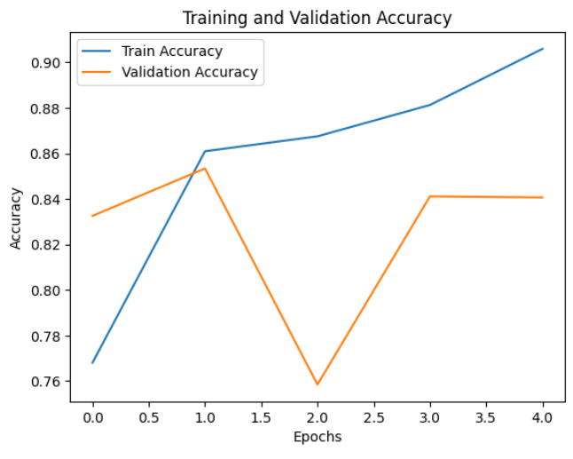
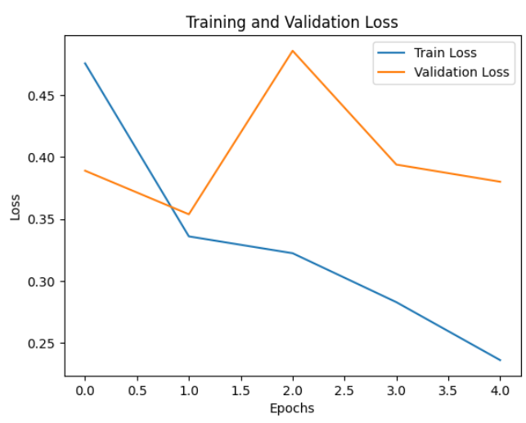
Multi-Class Sentiment Analysis using LSTM
# Step 1: Import Libraries
import numpy as np
Pandas = Python Data Analysis Library — it provides DataFrame structures for tabular data.
🔹 Why it’s used here:
To load and manage text and sentiment data easily from a CSV file or dictionary.
import pandas as pd
import matplotlib.pyplot as plt
from tensorflow.keras.preprocessing.text import Tokenizer
from tensorflow.keras.preprocessing.sequence import pad_sequences
from tensorflow.keras.models import Sequential
from tensorflow.keras.layers import Embedding, LSTM, Dense, Dropout
from tensorflow.keras.utils import to_categorical
from sklearn.preprocessing import LabelEncoder
Scikit-learn is a library for machine learning preprocessing and evaluation.
Why it’s used here:
To help with label encoding, data splitting, and metrics.
Function | Purpose
LabelEncoder() | Converts text labels (Positive, Negative, Neutral) into numeric codes (0, 1, 2).
train_test_split() | Randomly splits dataset into training and testing sets for evaluation.

from sklearn.model_selection import train_test_split
from tensorflow.keras.callbacks import EarlyStopping
import tensorflow as tf
TensorFlow Callbacks and Utilities
Function | Role
EarlyStopping | Stops training automatically when validation performance stops improving.
model.compile() | Defines optimizer (Adam), loss function (binary_crossentropy / categorical_crossentropy), and evaluation metrics.
model.fit() | Trains the LSTM model.
model.evaluate() | Tests the model on unseen data.
model.predict() | Generates predictions for new input text.

print("TensorFlow version:", tf.__version__)
# Step 2: Load Dataset
# Option A: Built-in sample dataset
sample_data = {
"text": [
"I love this movie, it’s amazing!",
"This is the worst product I have ever used.",
"It was okay, nothing special.",
"The experience was fantastic!",
"Not bad, but could be better.",
"Absolutely terrible service.",
"I’m really happy with the results!",
"Mediocre performance, not impressive.",
"The food was delicious and the staff were friendly.",
"I didn’t like the quality at all."
],
"sentiment": [
"Positive", "Negative", "Neutral", "Positive", "Neutral",
"Negative", "Positive", "Neutral", "Positive", "Negative"
]
}
df = pd.DataFrame(sample_data)
print("✅ Sample dataset loaded successfully!")
# Step 3: Optional – Upload CSV file
from google.colab import files
Google Colab’s helper library to interact with your local files inside the notebook.
🔹 Why it’s used here:
To upload our own dataset file (like sentiment.csv) directly from our computer into Colab.

uploaded = files.upload()
df = pd.read_csv(list(uploaded.keys())[0])
print("✅ Custom dataset loaded successfully!")
# Step 4: Encode sentiment labels (e.g., Negative=0, Neutral=1, Positive=2)
label_encoder = LabelEncoder()
df['label'] = label_encoder.fit_transform(df['sentiment'])
num_classes = len(label_encoder.classes_)
print("\nLabel mapping:", dict(zip(label_encoder.classes_, range(num_classes))))
# Step 5: Text preprocessing
max_words = 5000 # max number of words to keep
max_len = 100 # max length of each sequence
tokenizer = Tokenizer(num_words=max_words, oov_token="<OOV>")
tokenizer.fit_on_texts(df['text'])
X = tokenizer.texts_to_sequences(df['text'])
X = pad_sequences(X, maxlen=max_len, padding='post', truncating='post')
y = to_categorical(df['label'], num_classes=num_classes)
# Step 6: Split into training and testing sets
from sklearn.model_selection import train_test_split
X_train, X_test, y_train, y_test = train_test_split(X, y, test_size=0.2, random_state=42)
# Step 7: Build LSTM Model
model = Sequential([
Embedding(max_words, 128, input_length=max_len),
LSTM(128, dropout=0.2, recurrent_dropout=0.2),
Dense(64, activation='relu'),
Dropout(0.3),
Dense(num_classes, activation='softmax')
])
model.compile(loss='categorical_crossentropy', optimizer='adam', metrics=['accuracy'])
model.summary()

# Step 8: Train Model
early_stop = EarlyStopping(monitor='val_loss', patience=3, restore_best_weights=True)
history = model.fit(
X_train, y_train,
validation_split=0.2,
epochs=10,
batch_size=32,
callbacks=[early_stop],
verbose=1
)

# Step 9: Evaluate Model
loss, accuracy = model.evaluate(X_test, y_test, verbose=0)
print(f"\n🧾 Test Loss: {loss:.4f}")
print(f"✅ Test Accuracy: {accuracy:.4f}")
# Step 10: Plot Training History
plt.figure(figsize=(12,5))
plt.subplot(1,2,1)
plt.plot(history.history['accuracy'], label='Train Accuracy')
plt.plot(history.history['val_accuracy'], label='Val Accuracy')
plt.title('Model Accuracy')
plt.xlabel('Epochs')
plt.ylabel('Accuracy')
plt.legend()
plt.subplot(1,2,2)
plt.plot(history.history['loss'], label='Train Loss')
plt.plot(history.history['val_loss'], label='Val Loss')
plt.title('Model Loss')
plt.xlabel('Epochs')
plt.ylabel('Loss')
plt.legend()
plt.show()

# Step 11: Predict Sentiment for New Text
def predict_sentiment(texts):
seq = tokenizer.texts_to_sequences(texts)
padded = pad_sequences(seq, maxlen=max_len, padding='post')
preds = model.predict(padded)
pred_classes = np.argmax(preds, axis=1)
results = label_encoder.inverse_transform(pred_classes)
for t, r in zip(texts, results):
print(f"Text: {t}\nPredicted Sentiment: {r}\n")
# Example predictions
test_sentences = [
"I love this movie, it’s amazing",
"It was an average experience, nothing special.",
"The product was disappointing and bad.I didn’t like the quality at all"
]
predict_sentiment(test_sentences)
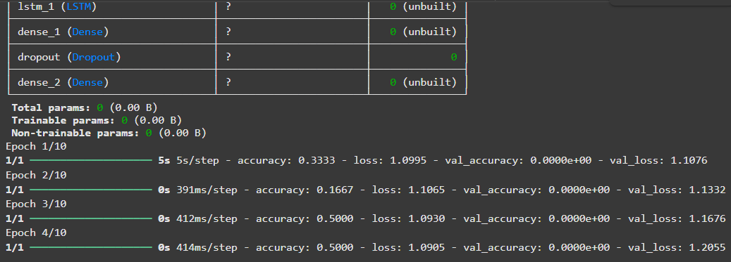
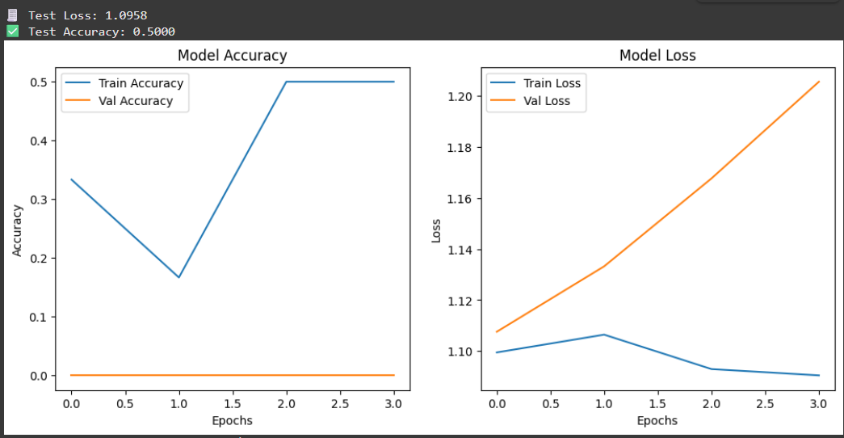
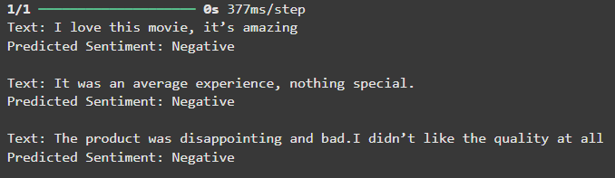

Assignment Question: How LSTM works in Sentiment analysis?

LSTM (Long Short-Term Memory) networks are advanced versions of RNNs designed
to remember long-term dependencies and avoid forgetting earlier context in a
sentence.
Explanation:
1. LSTMs processtext word by word while keeping track of important past
information (e.g., negations like “not”).
2. They use gates(input, forget, output) to control what to remember or discard.
3. During sentiment analysis:
o Wordslike “love”, “excellent” increase positive sentiment.
o Wordslike “worst”, “hate” increase negative sentiment.
o LSTM’s memory capturesthese contextrelationships acrossthe
sentence.
4. Finally, the Dense layer with a sigmoid (binary) or softmax (multi-class)
activation outputs the sentiment.

